**Moodle instructions to access healthcare innovation careers & pathways**

Link: [Course: Precision Medicine & Healthcare Innovation careers | .](https://glasgowonline.gla.ac.uk/course/view.php?id=320)

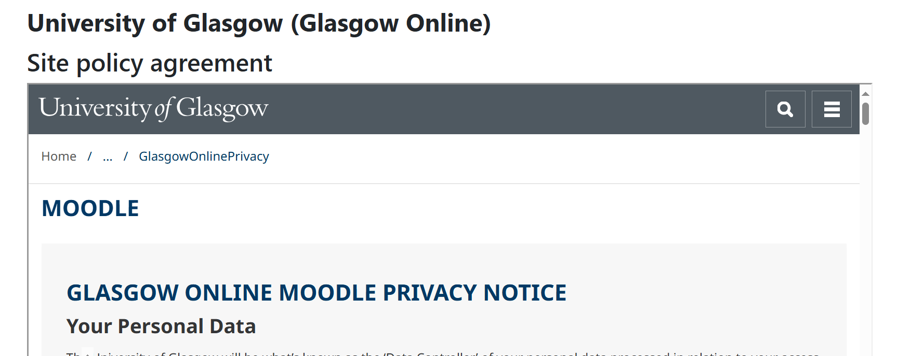

Scroll down using this bar.

Click: ‘Yes’

Enter webpage:

Explore healthcare innovation careers and activities.

Start with this section to learn about career cards.



Use ‘Who am I?’ and the Patient’s pathway to further engage your learners.



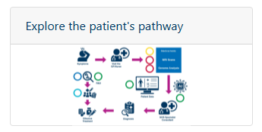

Any feedback or questions?

Please email: [living-laboratory@glasgow.ac.uk](mailto:living-laboratory@glasgow.ac.uk)