Moodle Basics for Students

This guide covers all the essential basics that you need to know about using Moodle as a student. This guide will not cover subject-specific or specialist topics but will provide important, basic information for University of Glasgow students.

Please note: the use of the Moodle app is not supported at the University of Glasgow. Our Moodle is designed to be accessed via a browser, either on a laptop or on a phone. You can find more information about this on the UofG Moodle site.

Table of Contents
Accessing and logging in to Moodle 1
Navigating through core Moodle functionality 2
Dashboard 2
Moodle dashboard customisation 2
My courses 6
Navigating Moodle inside a course 8
Key information: 10
Assessments 13
Turnitin 16
MyGrades (beta) 17

Accessing and logging in to Moodle
Moodle can be accessed via more than one route:
- Student portal page
- Directly typing the hyperlink in your browser (www.moodle.gla.ac.uk)

When you log into Moodle with these methods, you will be redirected to log in via single sign on (SSO) as shown below. This allows you to use your normal University log in (your GUID) to access University systems without needing multiple log ins. If you are already logged in, you won’t need to sign in again.

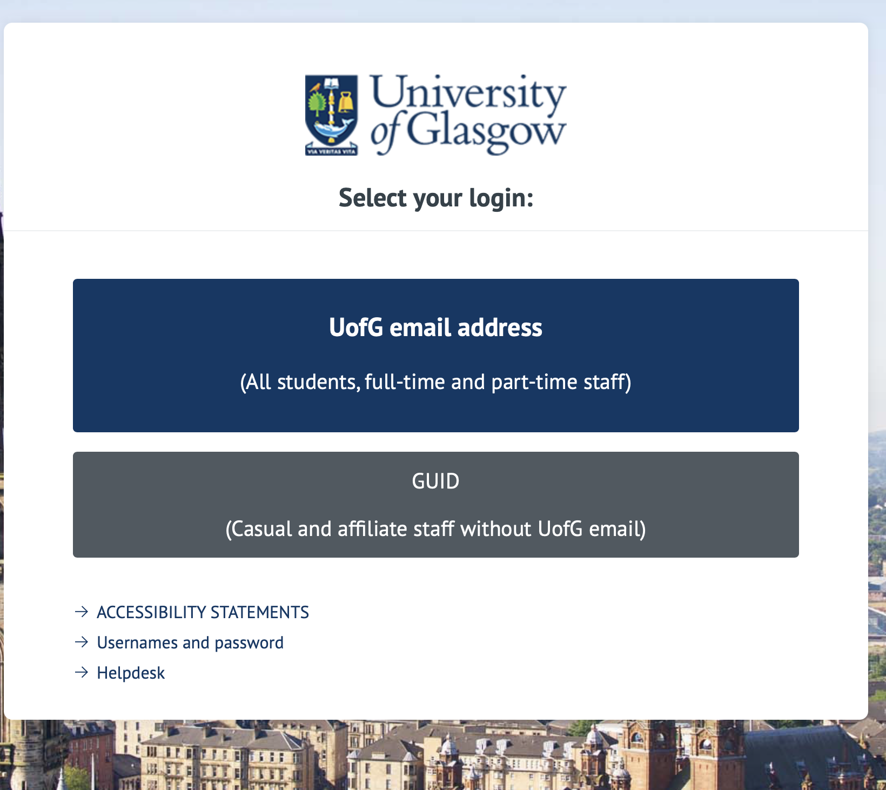

Navigating through core Moodle functionality

Dashboard

When you first log in using either the student portal or the web link above, Moodle will load on your dashboard:
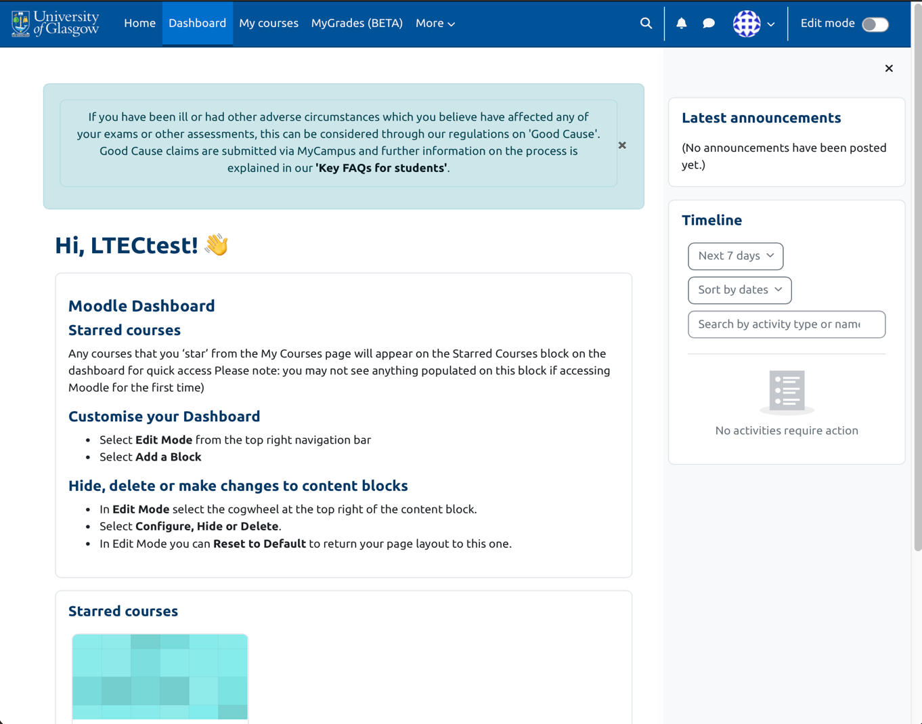


From here, you will be able to navigate to all of your courses, see any announcements and find any of your starred courses. The screenshot above shows you the default view with no customisation.

Moodle dashboard customisation
If you would like to change anything, Moodle gives you instructions. Once you turn edit mode on, you will be able to see that the option to add blocks shows up:

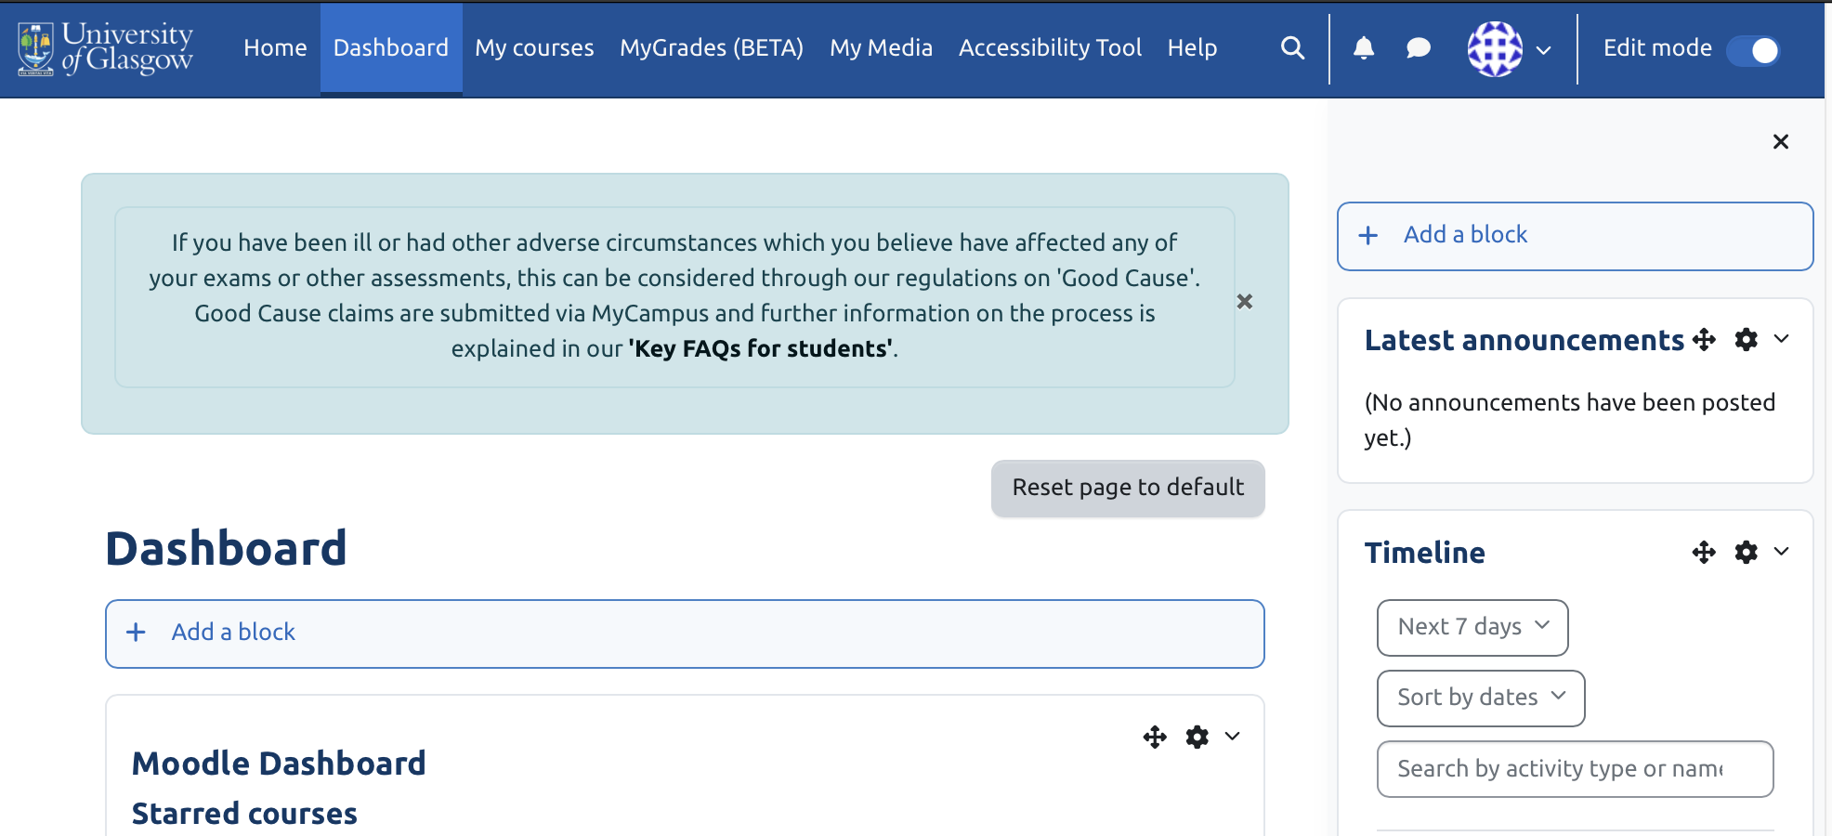

The blocks that you can add to the main section are shown below:

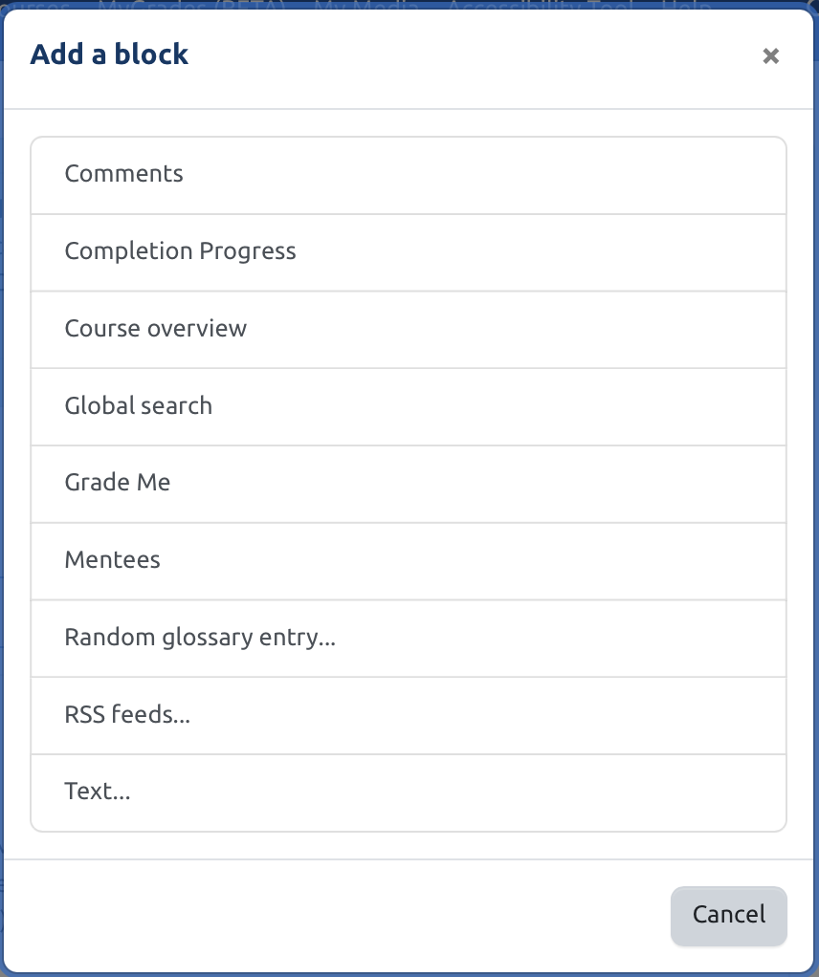

Once you click one, it adds it to the bottom of the screen:
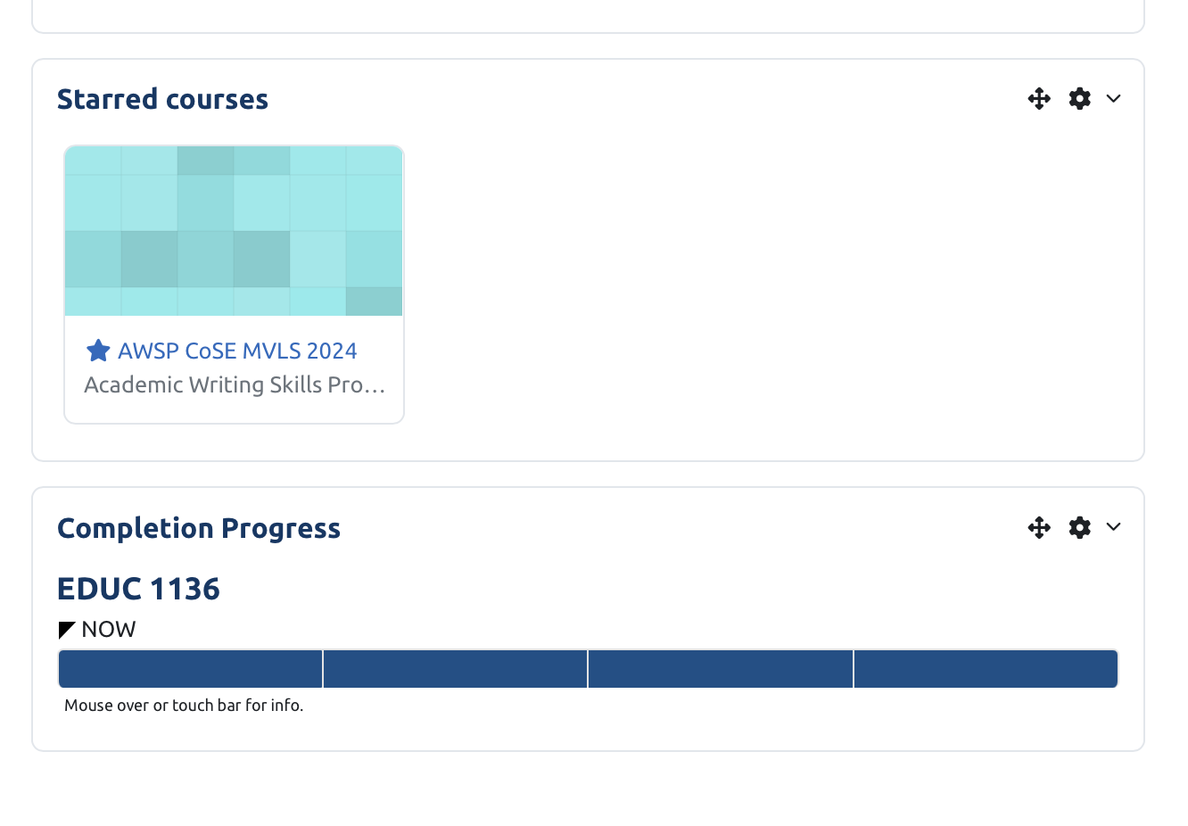

You can also add any of these blocks to the right-hand section.

To change, alter or delete any of the blocks, click the settings cog on the top right-hand corner:
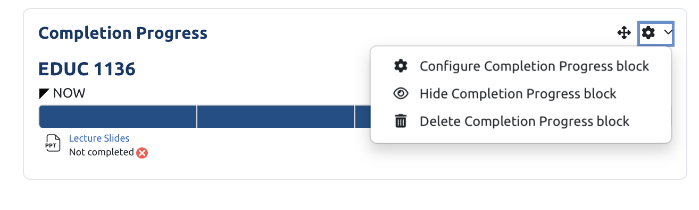

These screenshots are all taken on a laptop sized screen, but the options are exactly the same on the mobile web browser.
If you want to reset the entire dashboard there is a button at the top that appears once you’ve made changes entitled ‘reset page to default’:
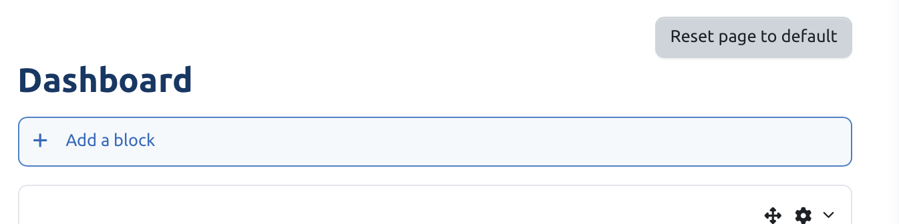

Selecting this will reset the page and turn edit mode off. If you wish to turn edit mode off without resetting the options, simply select the edit mode button at the top to switch it off.

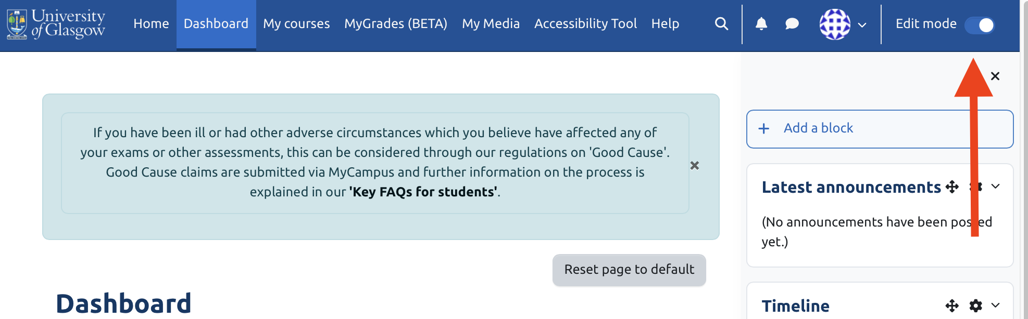

My courses
‘My courses’ is where you will find all the courses that you’re currently enrolled on.

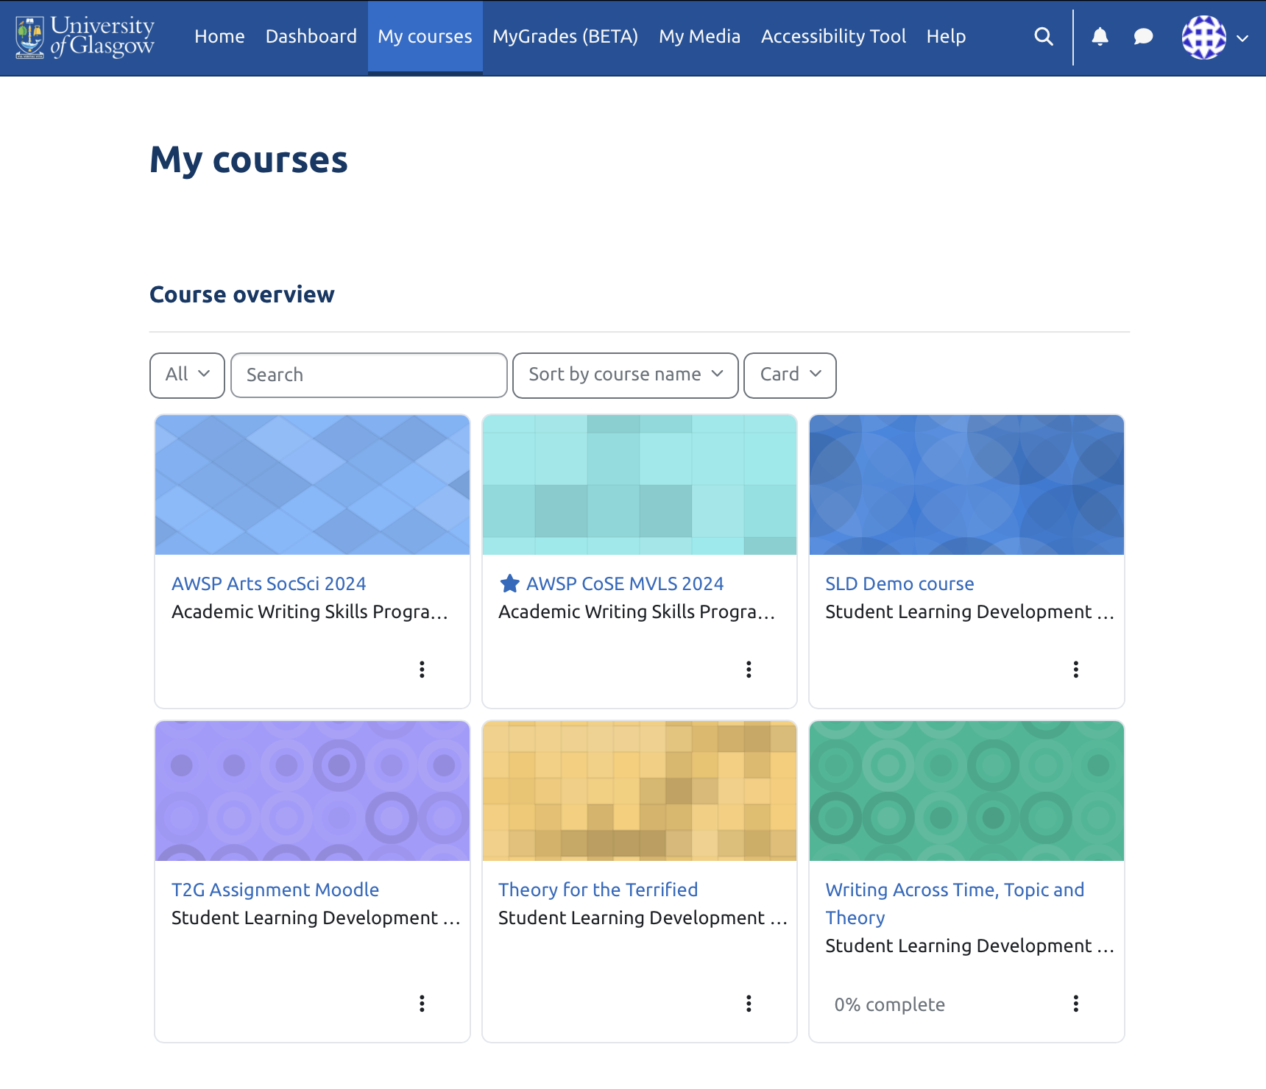

Out of the options above, dashboard is where you can find any courses that you’ve starred (this will be explained below), and ‘My courses’ is where you can find all the courses you’re enrolled on. Starring a course makes it easier to find if you access them often:

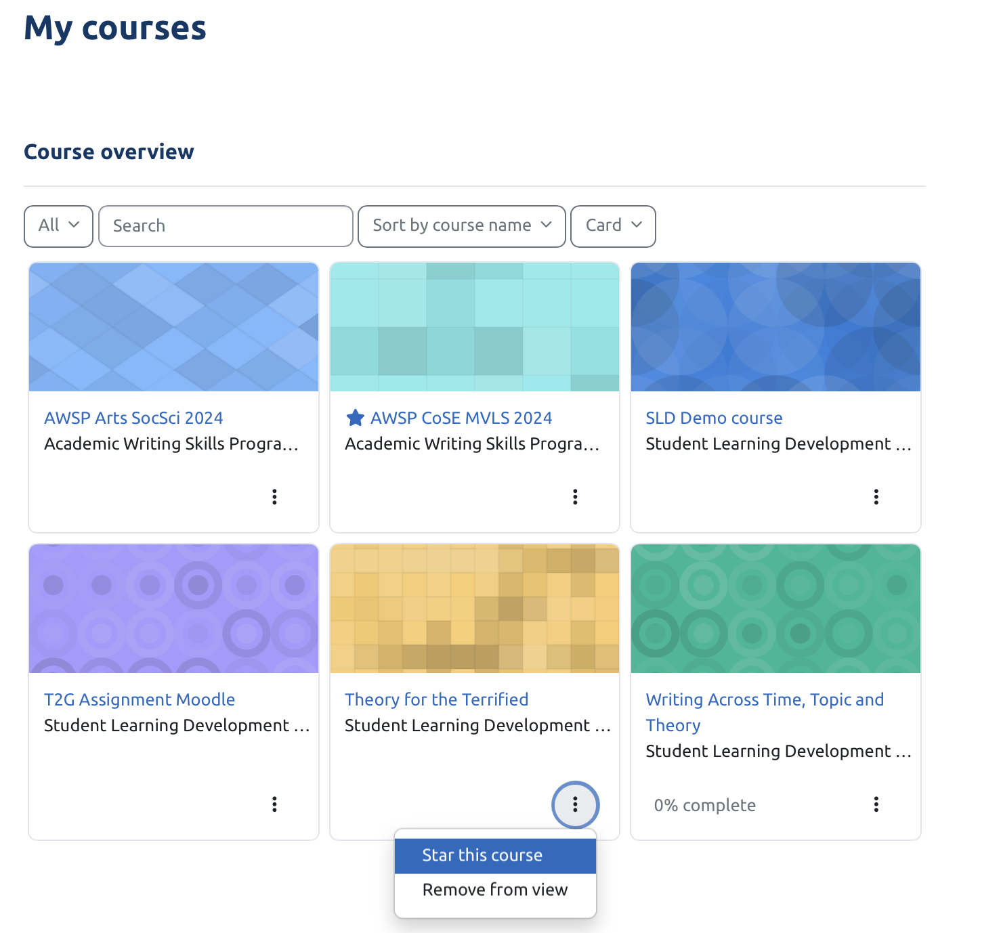

This will then allow your frequently accessed courses to appear in your dashboard:

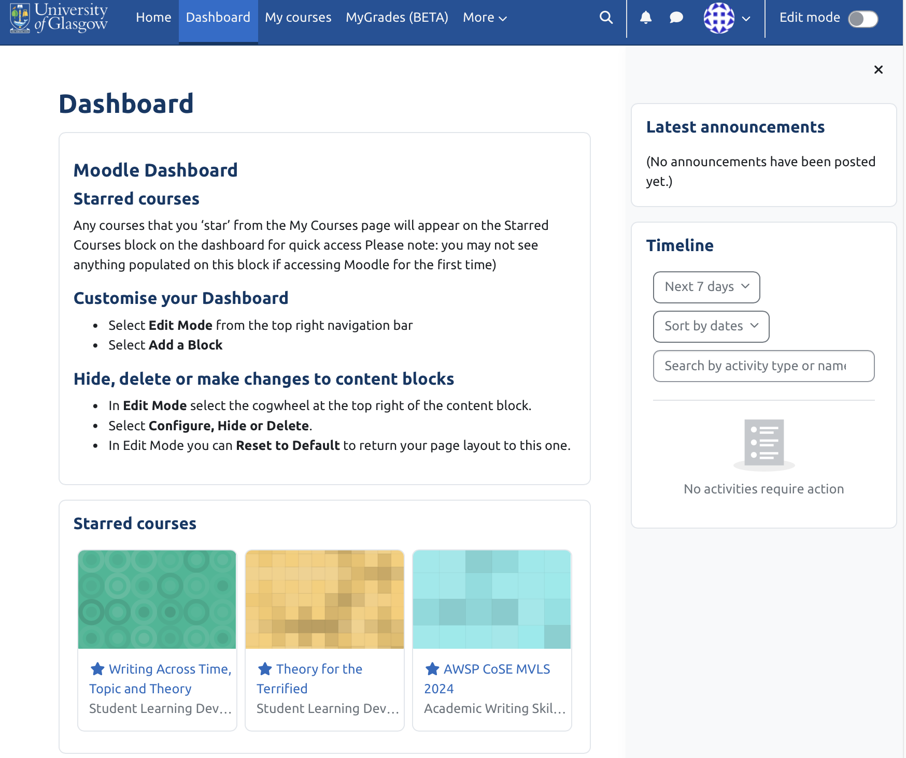

Navigating Moodle inside a course

Most Moodle courses at the University of Glasgow are standardising their approach and following the same template. This means that you can reasonably expect to find most of your courses to look fairly similar in terms of layout.

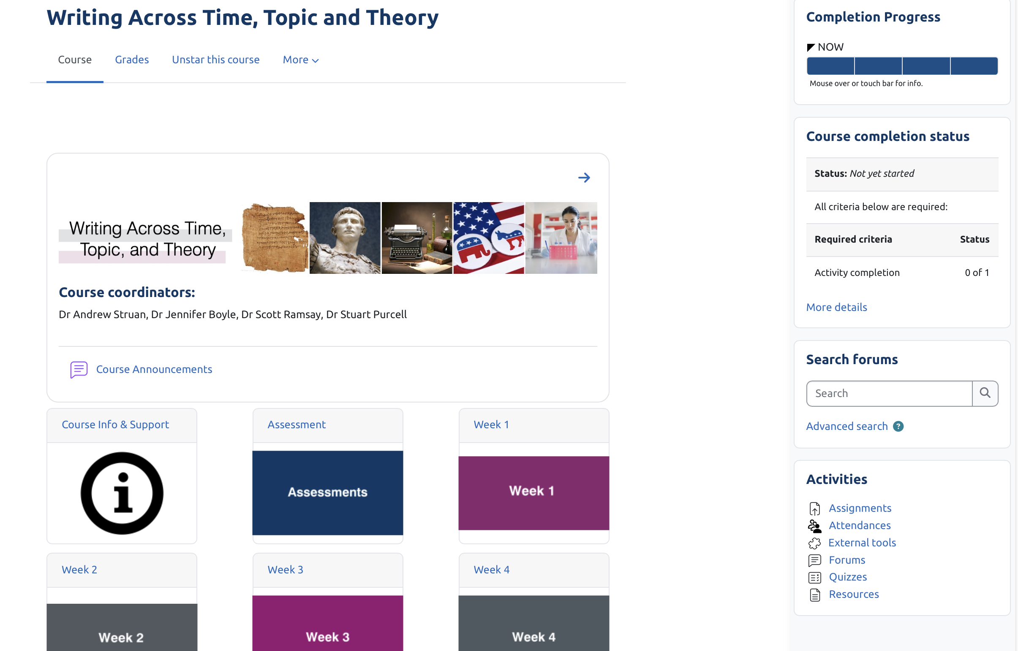

This course is set up in a grid layout. You might also find other layouts such as collapsed topics:

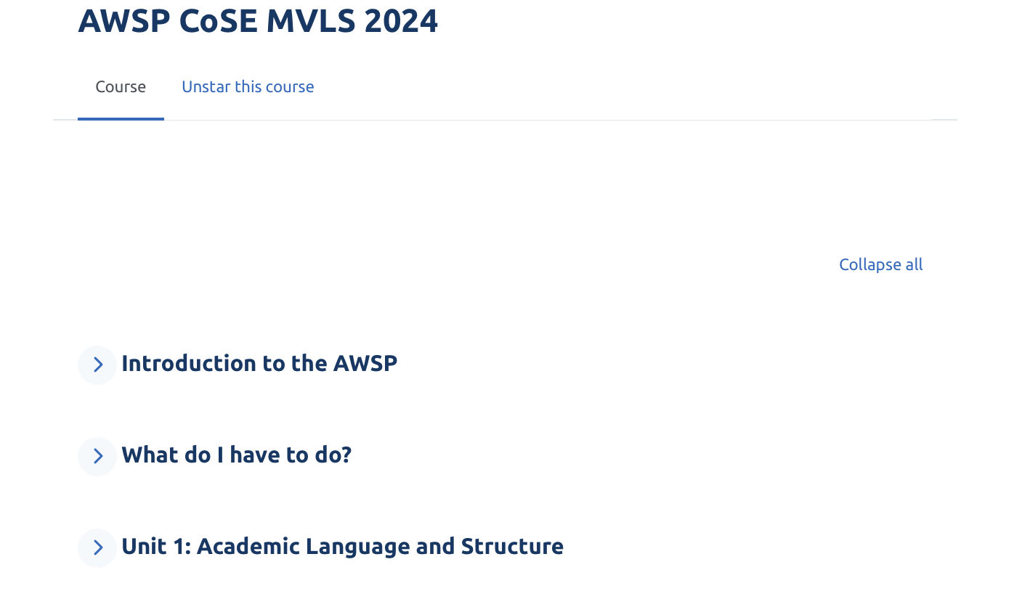
Collapsed topics also looks very similar to weekly topics:
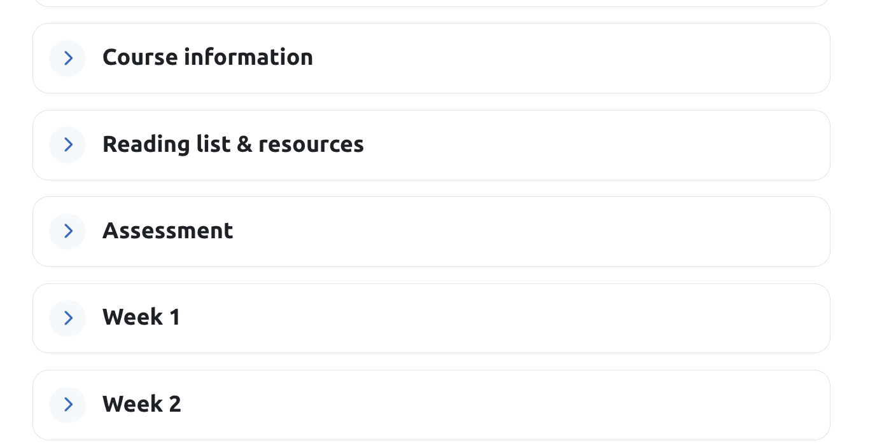

Tile format:

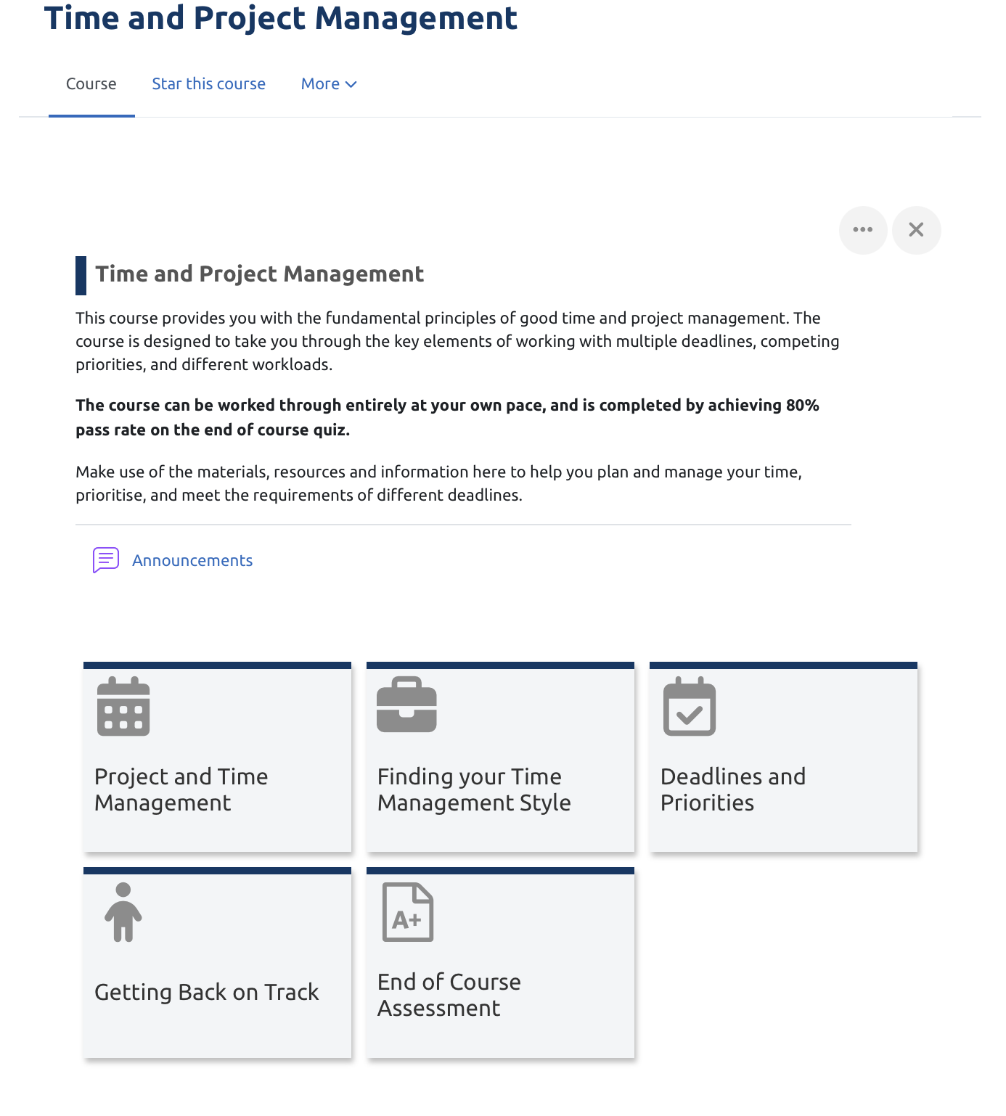

Most SLD courses will follow the grid format, but other schools and subject areas might have a preferred default.

Key information:

Below is a typical, grid-layout format course. In this, you would expect to see a general top section where you’d find your course announcements:
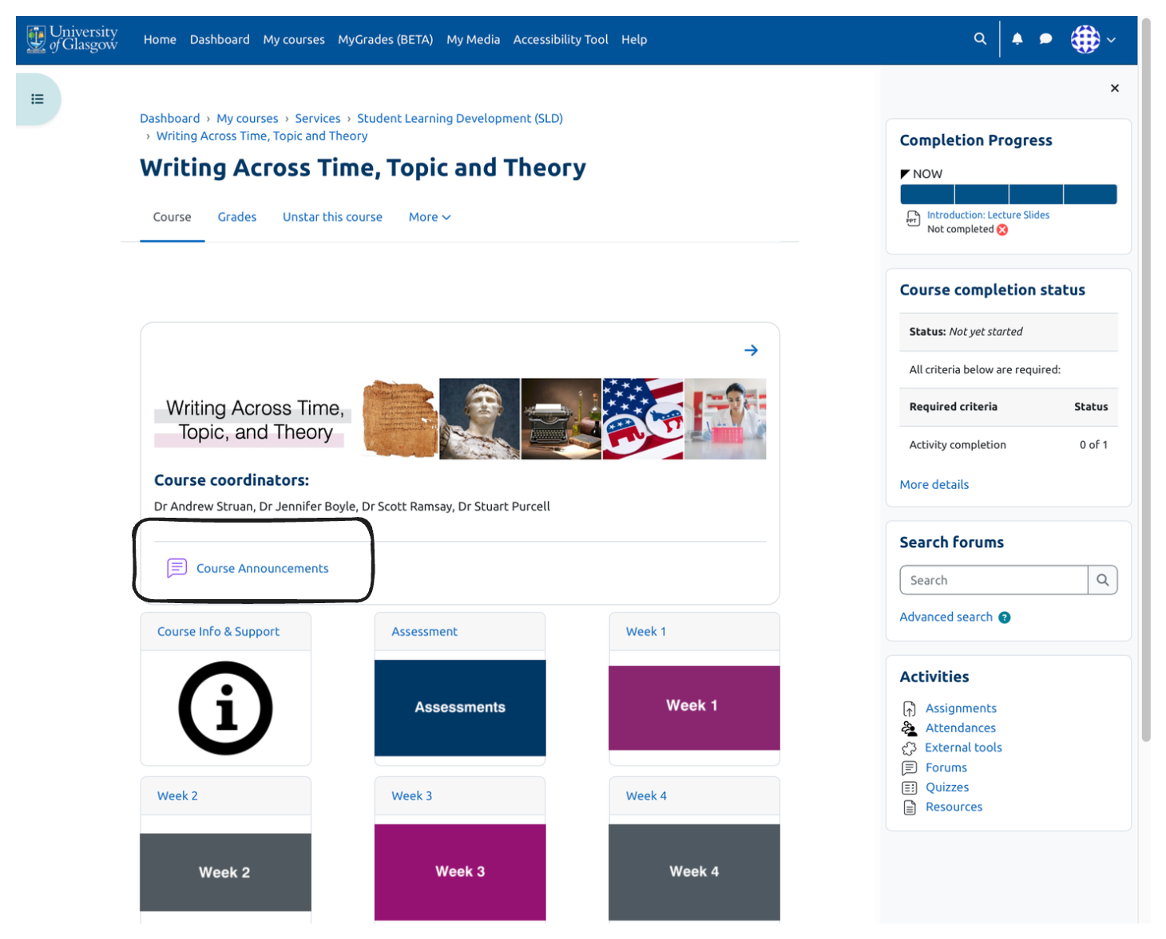

Your course lecturers and staff will likely use course announcements to send you notifications about important information relating to your course, lectures, assessment or anything else. Usually these will come as an email as well, potentially as part of a Moodle digest.

The other two most important elements are your course information and support section and your assessment section, highlighted below:

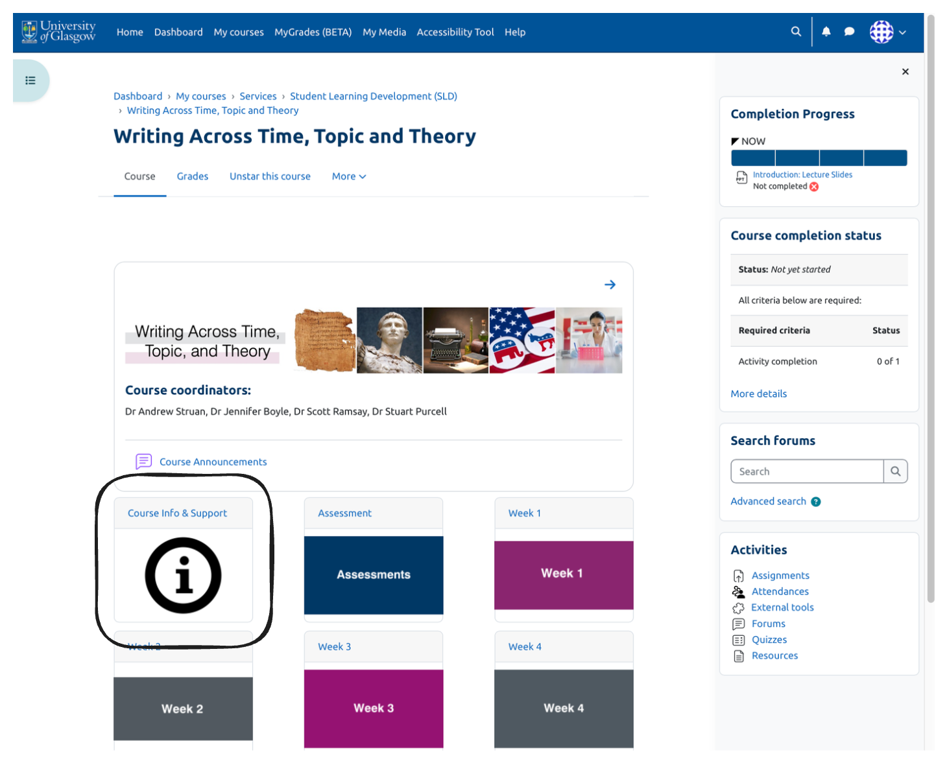
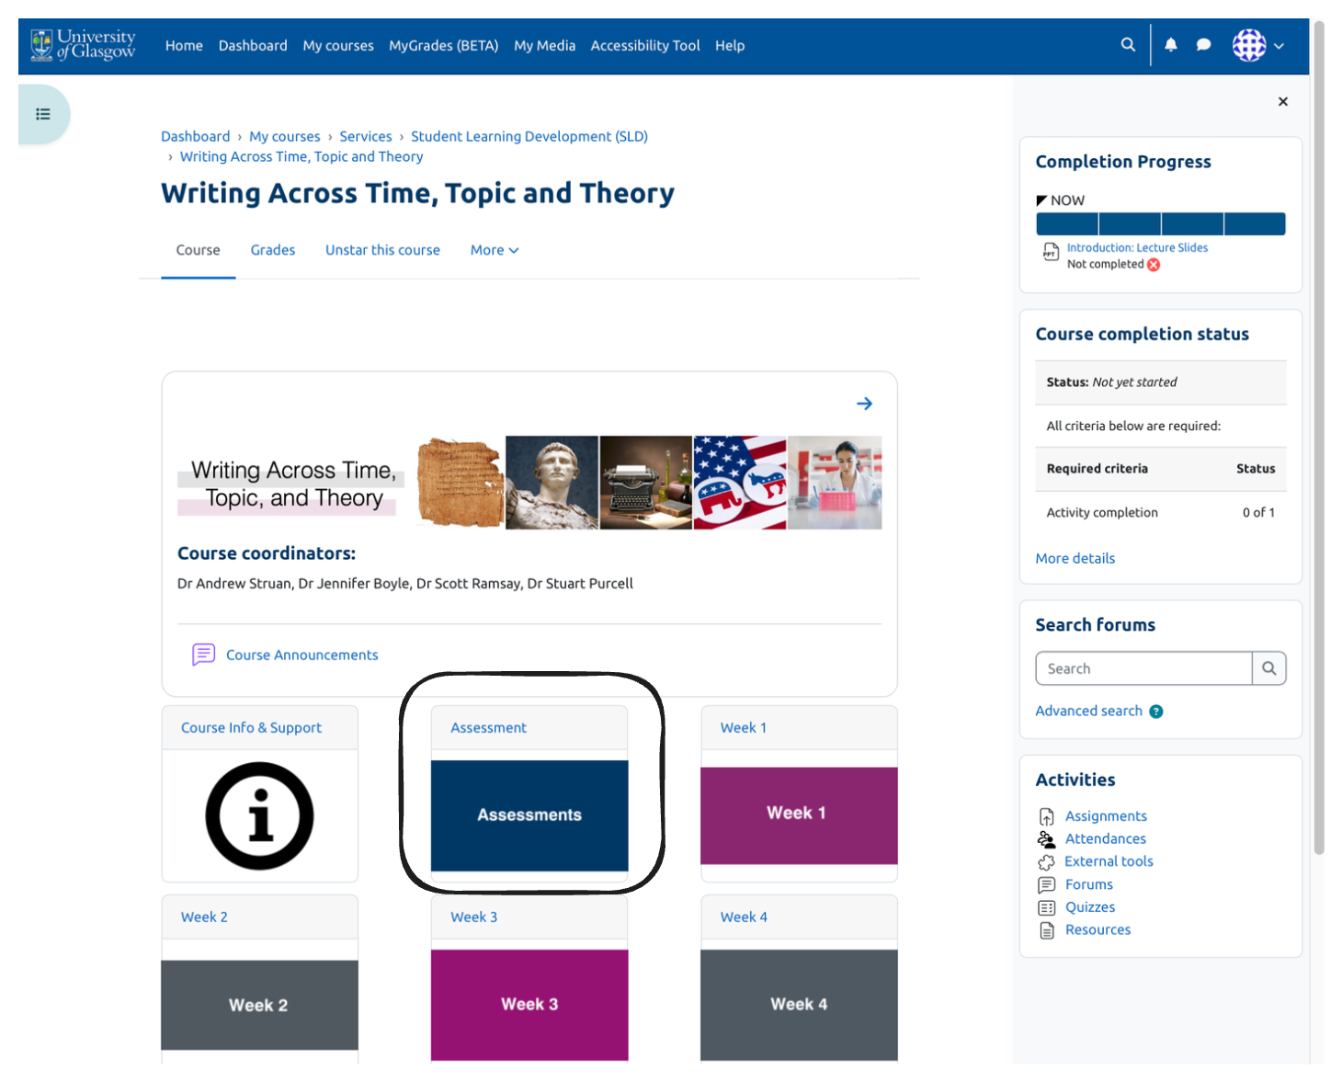

These are usually the first two sections you will find inside a Moodle course. If you don’t see sections exactly like these, don’t panic; the information typically inside these should still be inside your Moodle course but they might be in a different location.
Course information and support should contain things like your teaching staff details, course handbook with the intended learning outcomes (ILOs), the reading list (if applicable) and other similar information like the course timetable.

The assessment section should be where you find the locations and information about each of your assessed components for this particular course.

Grades, if applicable, can be found in the location of the screenshot below. This will take you to Moodle Gradebook for this course only to allow you to see your grades at a glance.

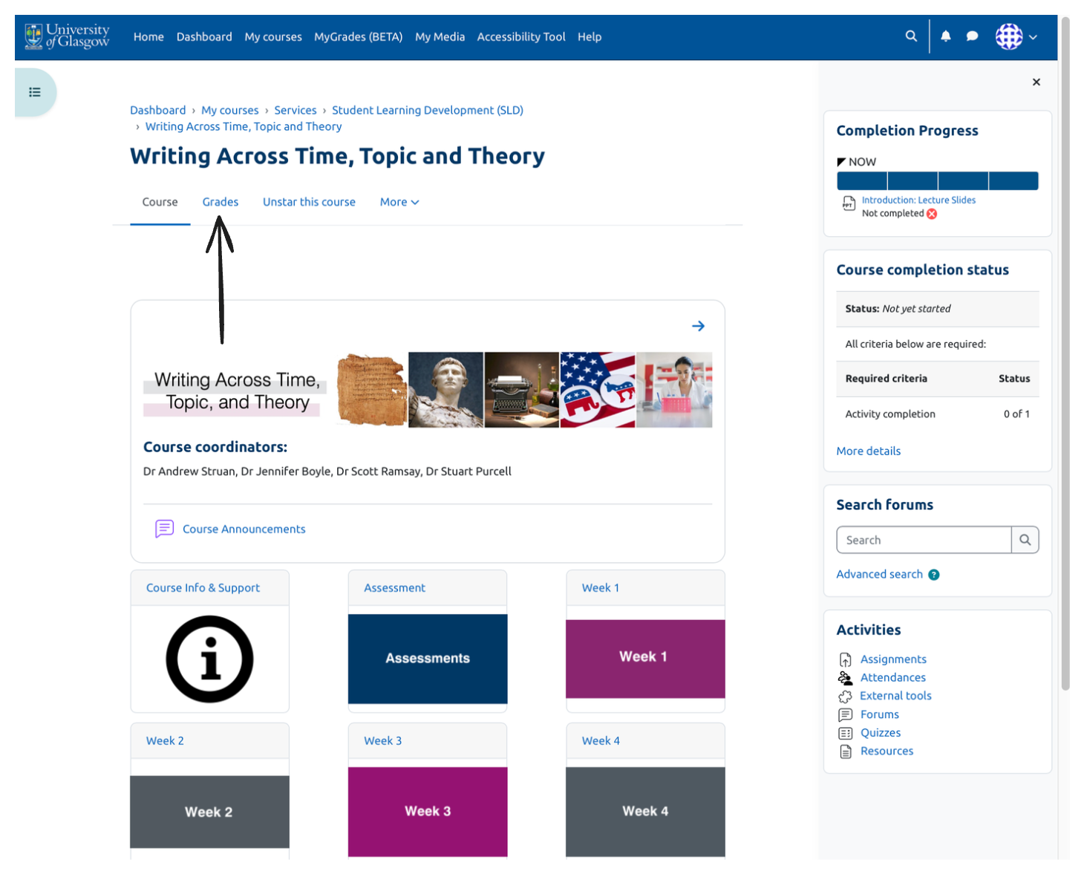
Other useful things to know: Moodle will sometimes open with one or other of the two side menus open. You can see that in the screenshot below, the one on the right is open and the one on the left has defaulted to closed. You can choose to see or hide both of these if you prefer.

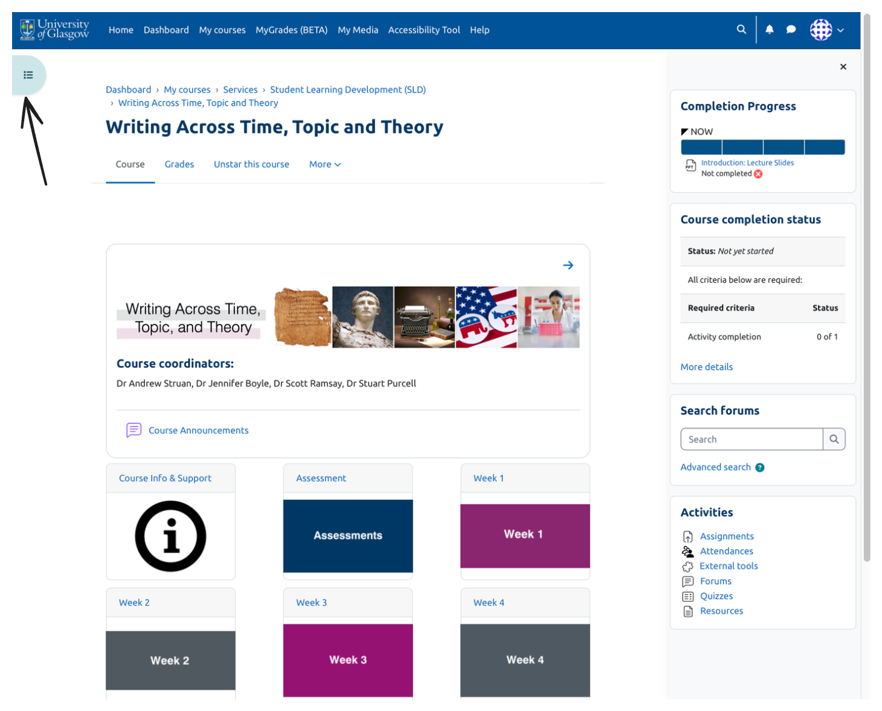

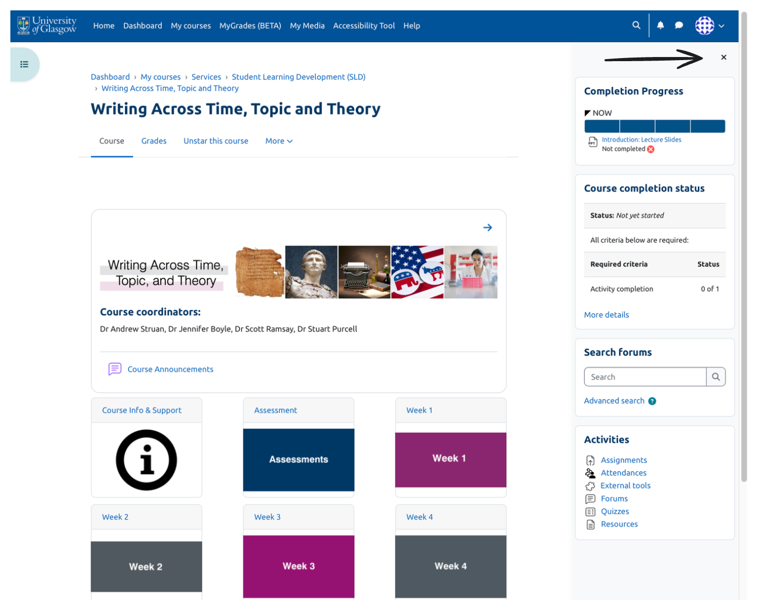

Assessments
Here we will cover typical assessment types and what they look like. We will not cover subject specialist assessment types.

Assignment
Moodle Assignment is the most used online assessment tool in the University. If you have written work to submit for your course, you will most likely need to submit it via Assignment.

When you click into an assignment, this is the page you will see:
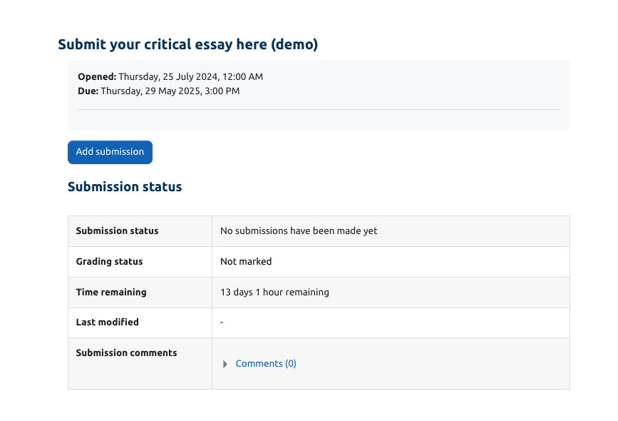

It will tell you when it opened, when it’s due, whether you’ve made a submission, the grading statues and how long you’ve got before the deadline.
As you click ‘add submission’, you will be required to sign the declaration of originality statement, and you will be asked to upload your assessment file:
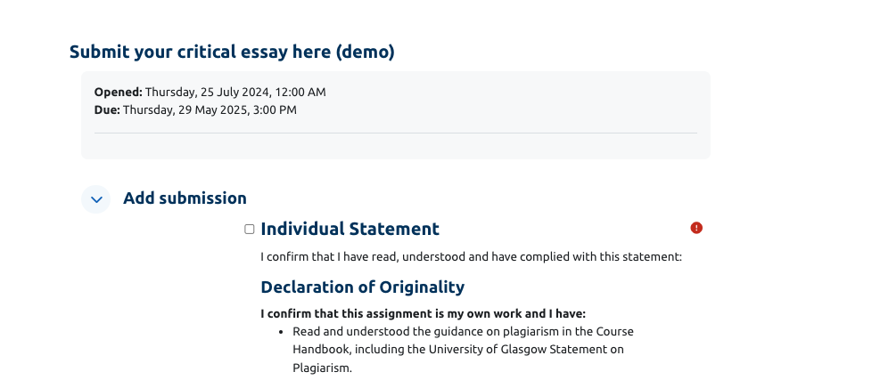

You should read through the whole declaration of originality before submitting. Don’t forget to tick the ‘individual statement’ box at the top, or you won’t be able to submit your assessment.

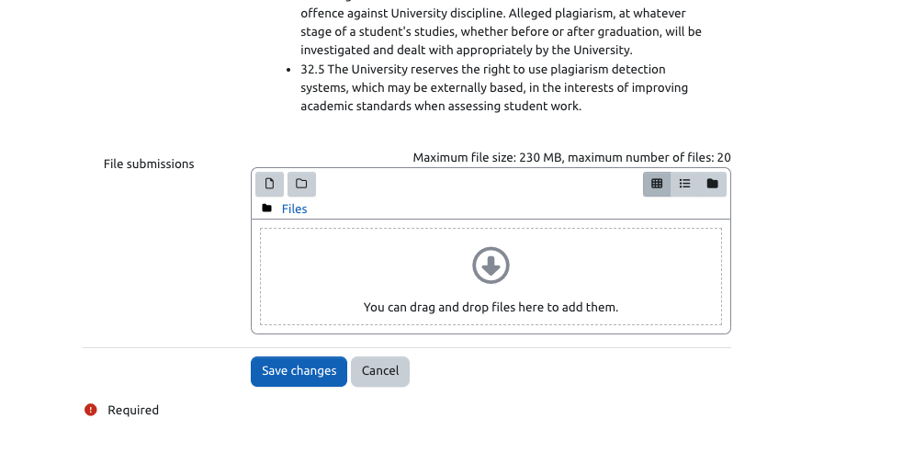

Quiz
Quiz is the next most commonly used assignment type at the University. When you click onto a quiz, you will see something similar to the following format:

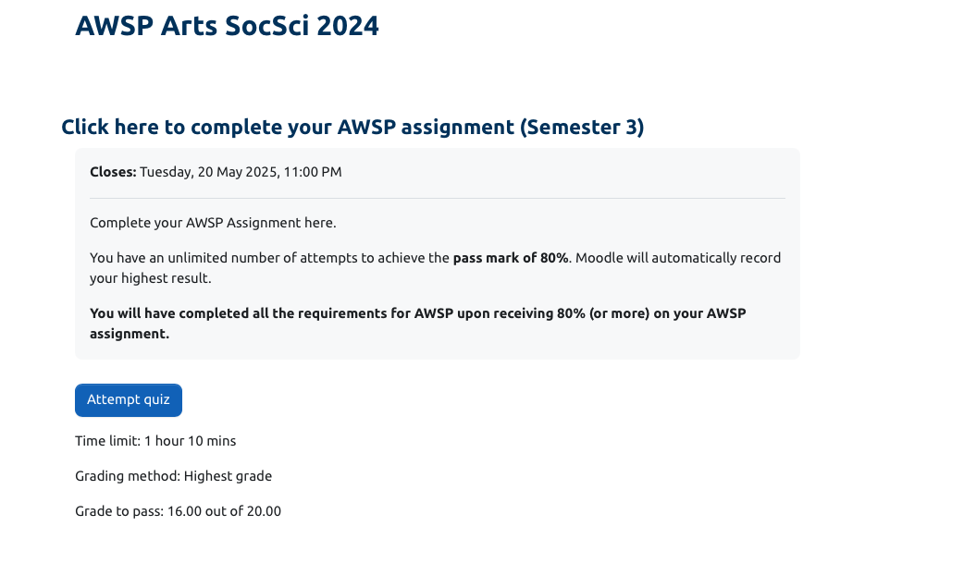

If your quiz is timed, when you click to start the quiz a warning will pop up telling you what the time limit is and letting you know that it’s not able to be paused.

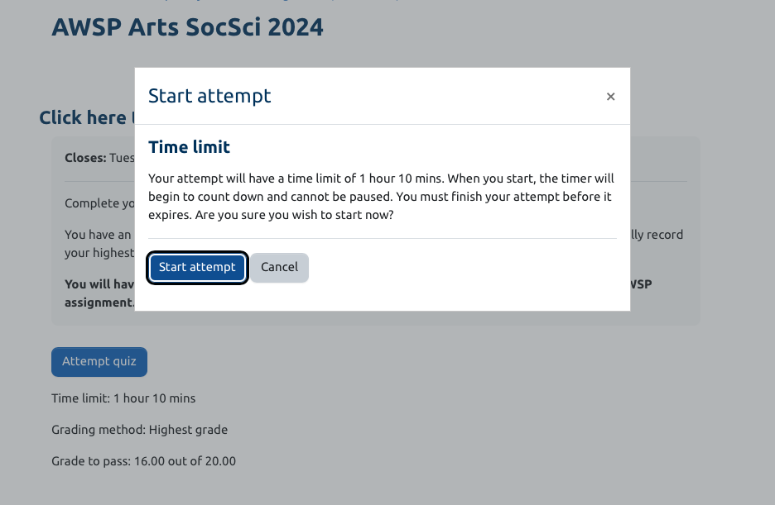

Turnitin
Turnitin is the University’s plagiarism checking software. You will often be asked to run your work through Turnitin when you submit an assignment.

Turnitin will give you a similarity score; it will check your work against work stored in its database and tell you how similar it is, thereby giving you a good approximation of how much it thinks you have copied others’ work. However, there are a couple of things to bear in mind that will drive your score up higher and are not things to worry overly much about:
- If you have included the assessment question at the top and are not the first person to submit the assessment
- If you have a lot of sources similar to those of your classmates, e.g., if you are a first year and were given a set reading list

We take academic integrity very seriously at the University of Glasgow. For more information, have a look at the plagiarism section on the SLD website. If you’d like more resources on plagiarism and academic integrity, you can find more resources, our open class timetables, or make a 1-1 appointment on the SLD website.

What happens when I submit work to Turnitin?

Your course might have the option for you to submit a draft piece of work through Turnitin before you submit your work for grading.
The purpose of this draft submission area is to allow you to have a look at your similarity score to check if you have made errors or missed citations before submitting your work into the proper area for grading.

The steps are as follows:
- Your course will have an assessment area set up – if you are submitting work through Turnitin, this will likely be an ‘Assignment’ area.
- Select the ‘draft submission area’
- Upload your assessment
- Wait for the email back from Turnitin to your University email address
- Carefully check through your work to see if you’ve made any errors

To submit your final assessment, the steps above are exactly the same but once you submit your work to the final assessment area, you won’t be able to edit it.

MyGrades (beta)
MyGrades for students is a new feature available to you as a student in Moodle at the University of Glasgow. This is a section in Moodle that will allow you to see all your grades from all courses (that have it enabled) in one location. At the time of writing, it’s possibleTurnitin that you might not see every single course, but you should be able to see the majority.
There are two key sections in MyGrades. The first thing you will see is the two charts showing you a visual about your assessments:

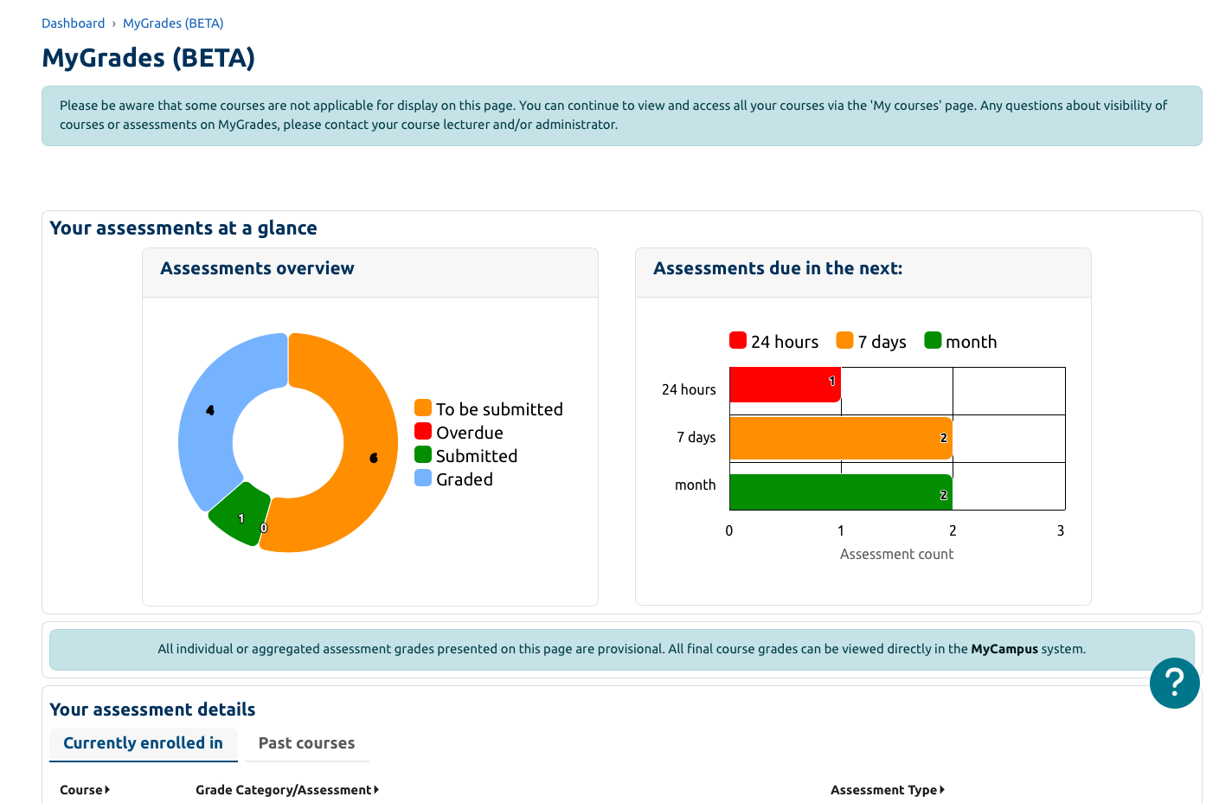

Underneath the header ‘your assessment details’, there is a table which will show you all your courses. For some of your courses, under the ‘course’ header, your course name will be your course code on MyCampus.
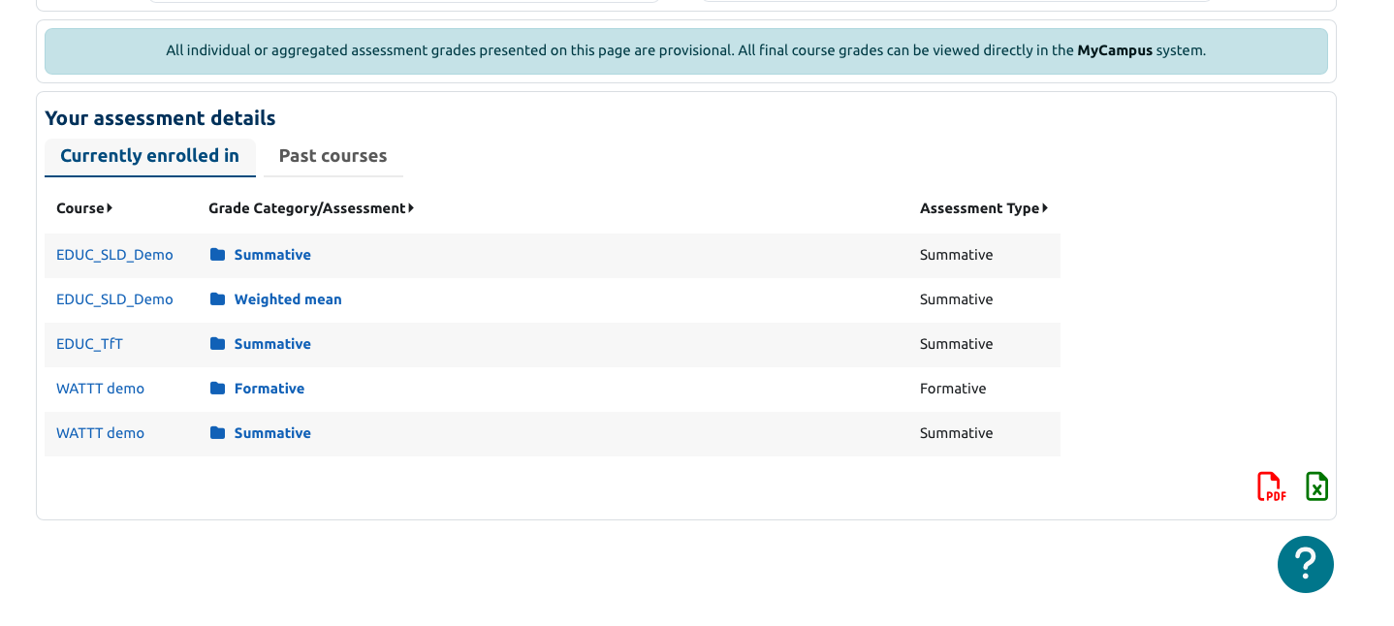

Clicking on the chart segments above will change the data you see in the table below. To access the deeper levels of the table, click on the sections inside the ‘grade category/assessment’ section:
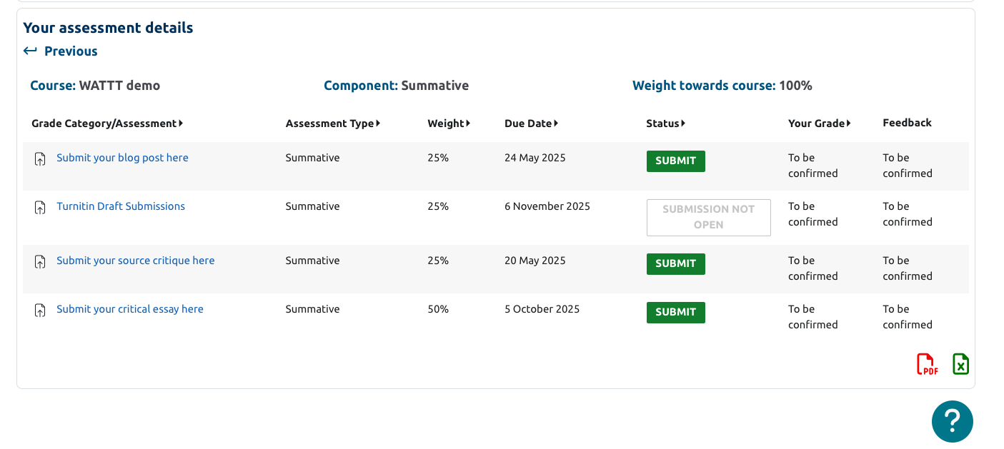

When your assessments have been graded for a course, this page will look something more like this:

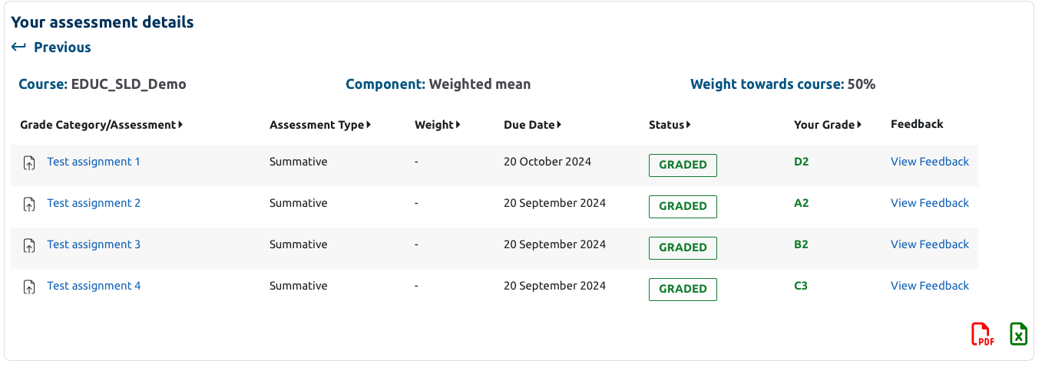

You can find more detailed information on the FAQs section on the SLD website.

