Professor Andy Schofield 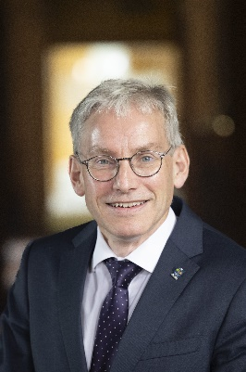
Principal

Professor Andy Schofield is the Principal and Vice-Chancellor of the University of Glasgow, having assumed the role on 1 October 2025. He succeeded Professor Sir Anton Muscatelli, becoming the University’s 51st Principal.

Prior to joining the University of Glasgow, Professor Schofield served as Vice-Chancellor of Lancaster University from May 2020. His earlier career includes senior leadership roles at the University of Birmingham, where he was Pro-Vice-Chancellor and Head of the College of Engineering and Physical Sciences.

His academic interest focuses on theoretical condensed matter physics. Professor Schofield specialises in correlated quantum systems, including non-Fermi liquids, quantum criticality, and high-temperature superconductivity. He studied Natural Sciences at Gonville and Caius College, University of Cambridge, where he also completed his PhD at the Cavendish Laboratory. In 1992, he was awarded a College Research Fellowship, followed by a postdoctoral position at Rutgers University in the United States. He later returned to Cambridge as a Royal Society University Research Fellow.

In 1999, he joined the University of Birmingham and was promoted to Professor of Theoretical Physics in 2002. Over the following years, he held a series of academic and strategic leadership roles at Birmingham, including Head of the School of Physics and Astronomy (2010-2015), culminating in his appointment as Pro-Vice-Chancellor (2015-2020).

Professor Schofield contributes to national research and policy through several key roles. He is the Senior Independent Member of the Science and Technology Facilities Council (STFC), Chair of the USS Employers Pensions Forum, and a Board Member of the Universities and Colleges Employers’ Association (UCEA). He is also an Honorary Fellow of the Manufacturing Technology Centre and a strong advocate for international collaboration through the UK International Campus Alliance Network (UK-ICAN).

