Martin Sinclair 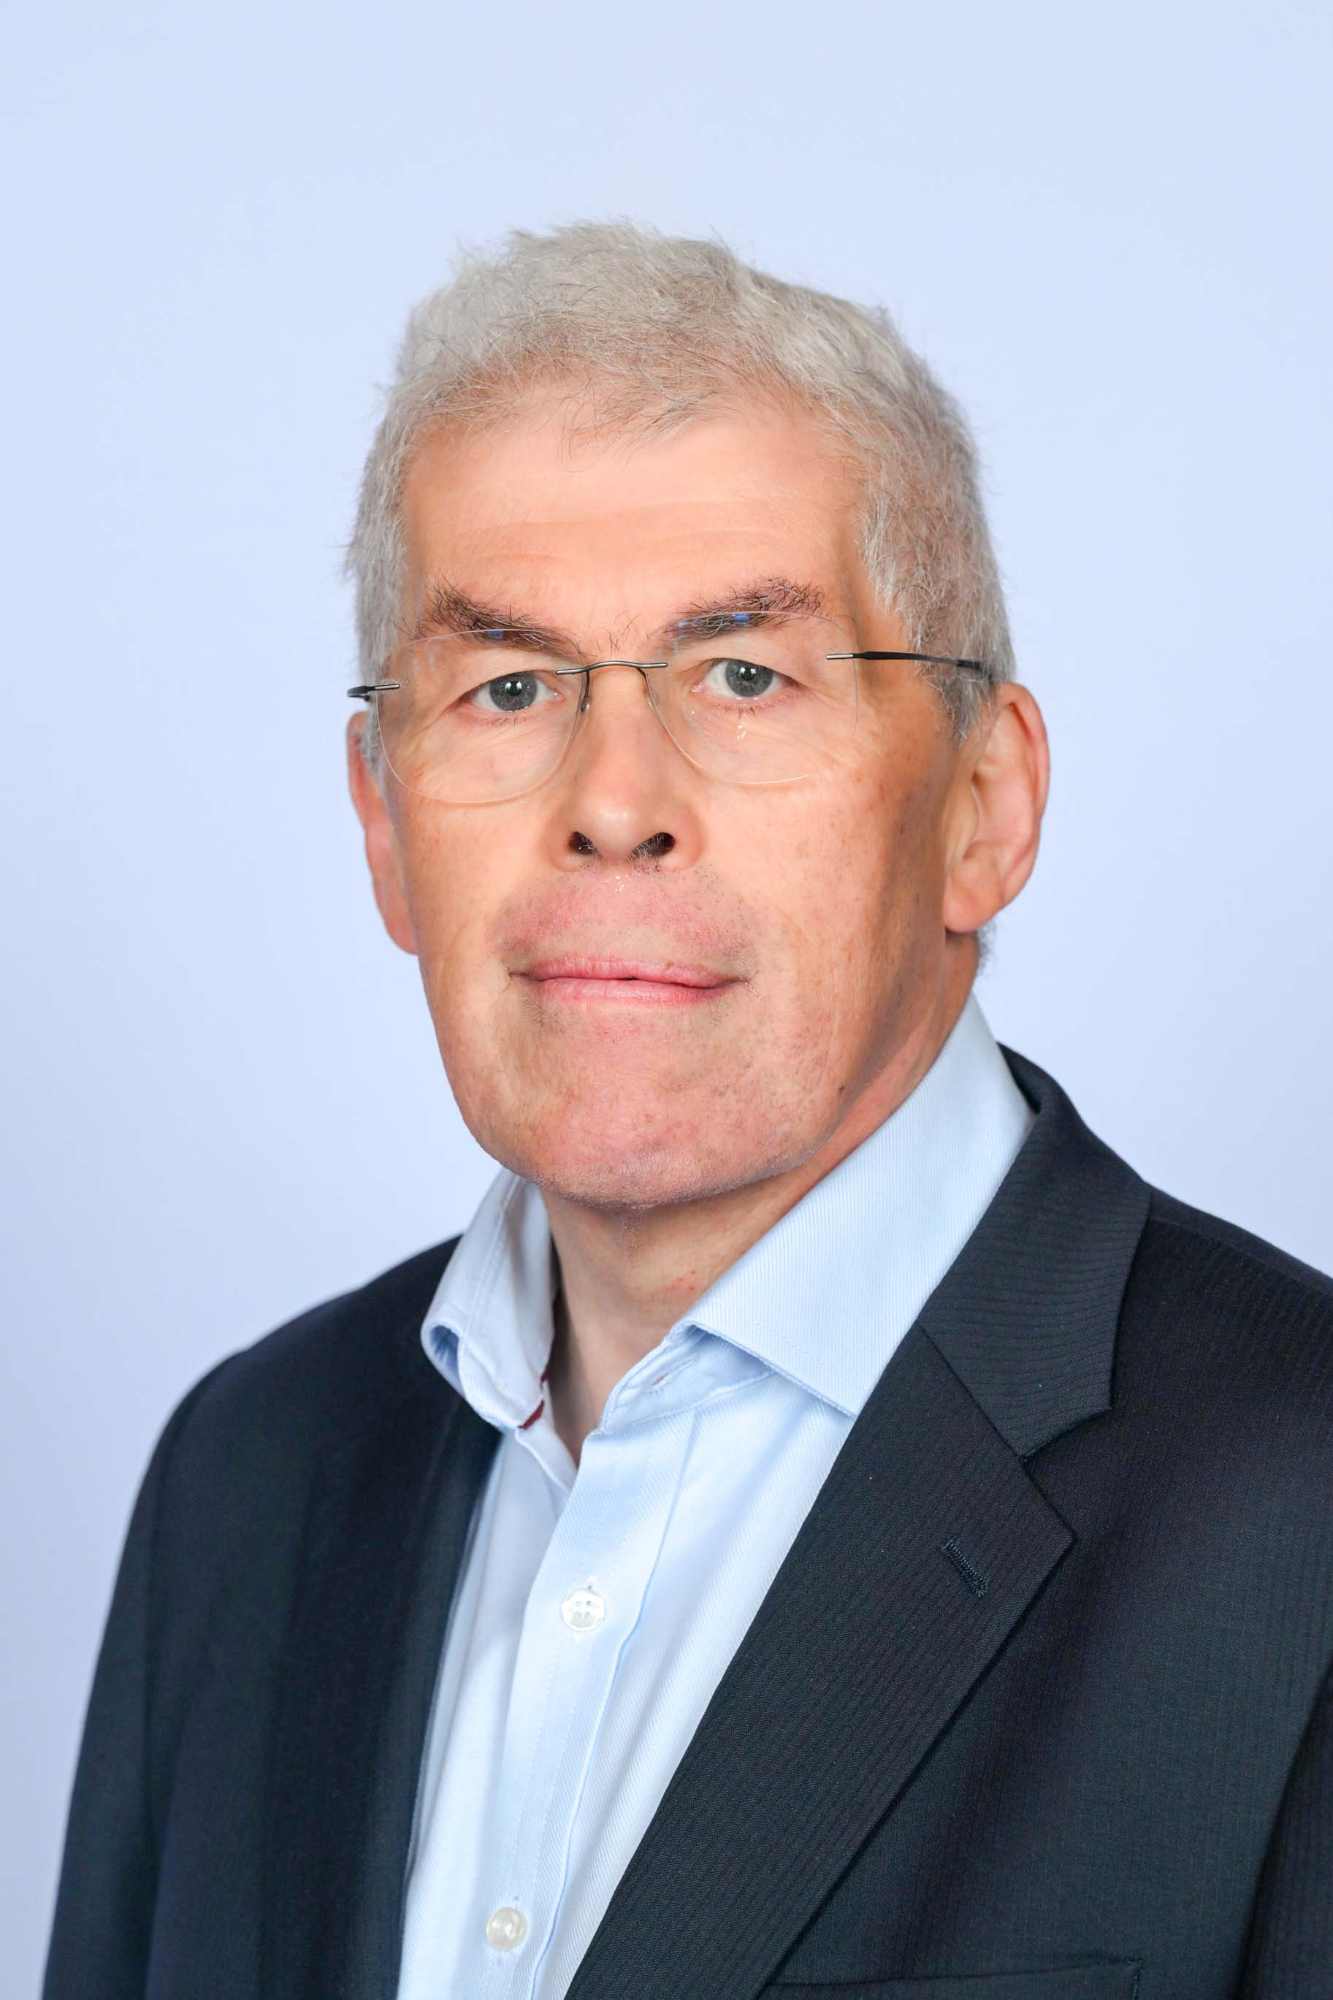
Co-opted Member

Martin is a graduate of the University in Geography. He is a qualified accountant and auditor with more than 30 years’ experience as an external auditor of central government working on behalf of the UK Parliament. For 15 years he was a Management Board Member of the National Audit Office (NAO). During that time, he led the NAO’s financial audit practice for 10 years and subsequently was Executive leader for National Affairs, a client portfolio embracing many of the major offices of State and a number of international organisations including the United Nations.

Since leaving the NAO, he has worked as a consultant in public financial management and corporate governance in a number of EU candidate countries and undertaken a various trustee and non- executive roles. These have included nine years as a trustee and Chair of the Finance and Audit Committee of Asthma UK and as a Non-Executive Director of two major NHS Trusts in the south of England. He was also for a time Treasurer of the Chartered Institute of Public Finance and Accountancy. He is currently a Trustee of Research Data Scotland. He is Chair of the University’s Audit and Risk committee.

