

Summer School 2026

Registration Guidance Notes

To register for Summer School, you’ll need to complete your registration through the University’s Direct Admissions System. This form does not replace your UCAS application and is only used for registering for Summer School. UCAS remains your go-to portal for your university application.

Please ensure that you are logged out of the Applicant Self-Service portal before accessing the Direct Admissions System as you’ll need to create a new account for Summer School registration.

The Direct Admissions Form for Summer School is broken down into several sections: Personal Details, Contact Information, Widening Participation, Source of Information, Submit, Application Overview.

Section 1: Register an Account on the Direct Admissions System

- Go to www.gla.ac.uk/summerschool and click Register Now to access the Direct Admissions System.

- Select Create New Account

- Please register with the same email address as the one on your UCAS application.

Note:
We will communicate with you using this email address prior to the programme beginning, so please ensure that you have access to this email address and that you check this regularly.

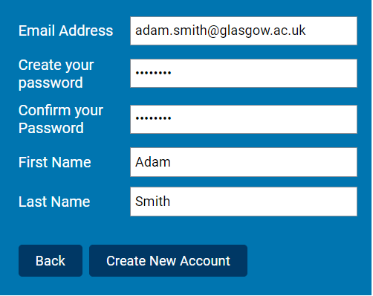

- Select your Country of permanent residence from the drop-down menu as United Kingdom – Scotland. The Mode of Study is Part-Time.

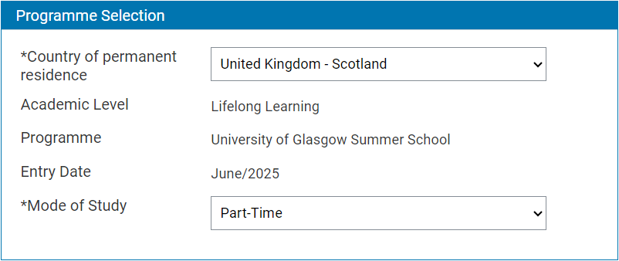
2026

Once you complete a section on the registration form, you will see a green tick on the menu on the left of your screen.

Note:
If you do not see a tick next to a section, this means that it is incomplete.

Section 2: Personal Details

- Please fill in your Personal Details

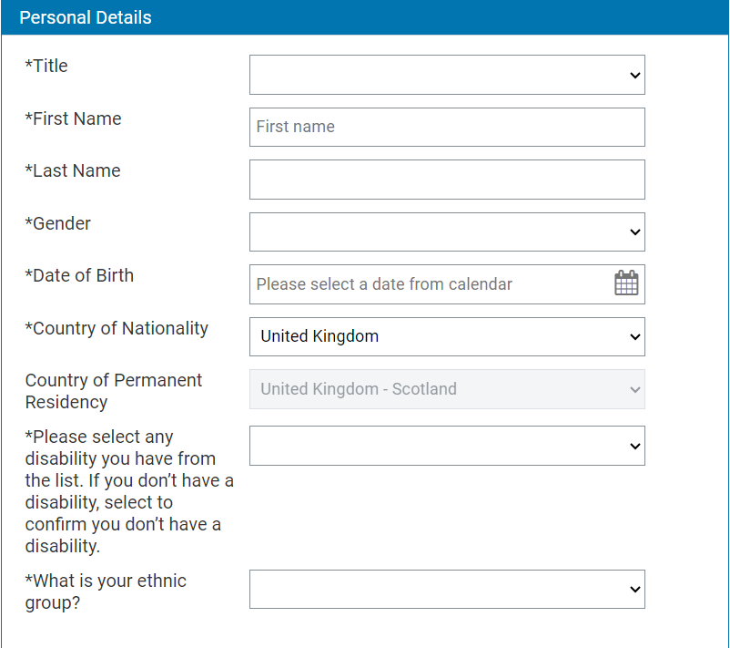

Section 3: Contact Information

- Fill in your Home Address, including postcode. You can click the button at the bottom of this section if your Mailing Address is the same as your Home Address.

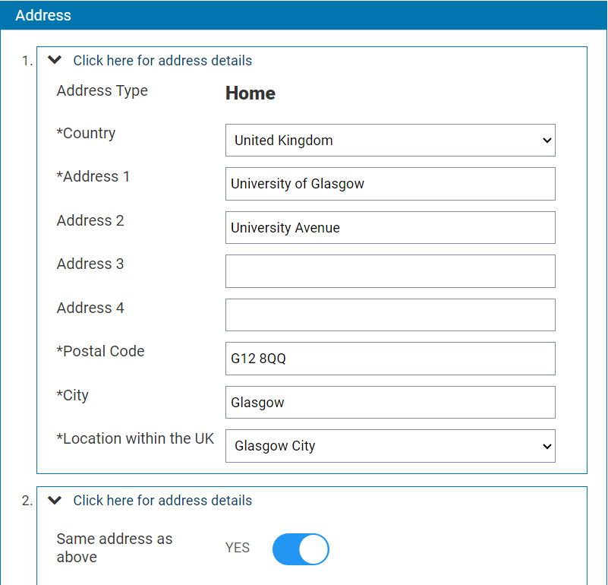

- Please input your Phone Number. Your Email Address will be automatically imported in from your login information.

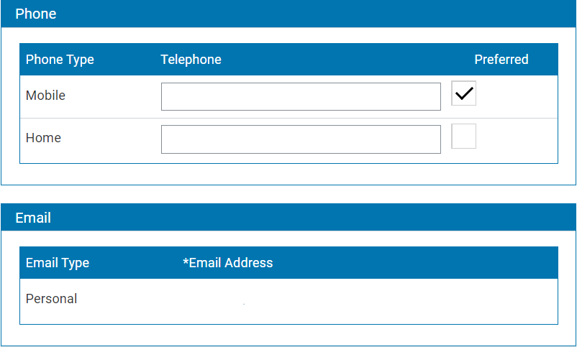

Section 4: Widening Participation

- If you meet any of the following Widening Participation criteria, please tick the boxes. There is no limit on the number of boxes you can tick.

If you do not meet any of these criteria, you can leave this part blank.

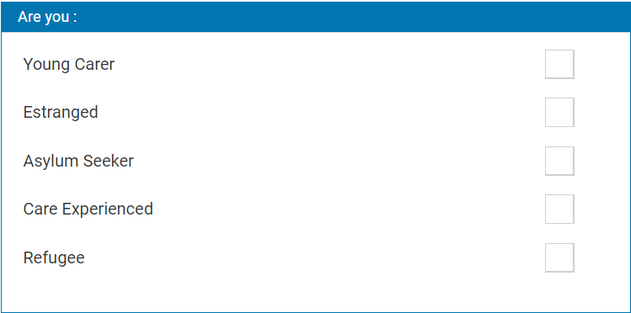

- If you are in receipt of any of the listed benefits, please indicate this. There is no limit on the number of boxes you can tick.

If you are not in receipt of any of these benefits, you can leave this part blank.

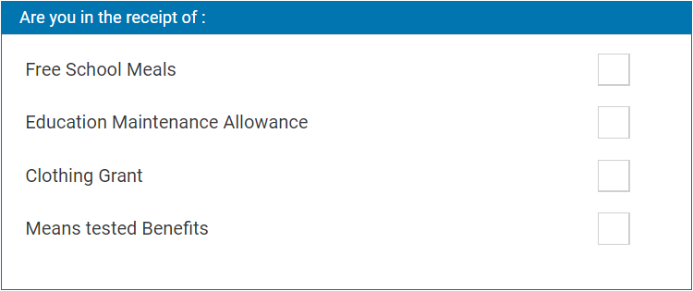

- Please indicate if you have any additional support needs and provide us with as much detail as you can so we can ensure that you receive the best possible support during Summer School.

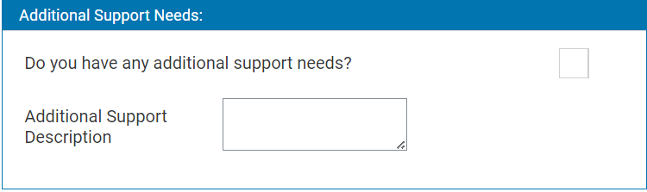

- If you are currently in school, please input your Local Authority (e.g. Glasgow City Council) and select your school from the drop-down menu.

If you are either attending college please type your college name (e.g. City of Glasgow College) in the text box. If you are not currently in education, write Not in Education.

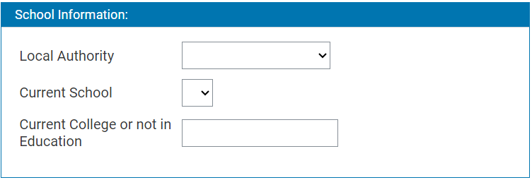

- Please input your Scottish Candidate Number (SCN) and UCAS ID, if known.

Note:
If Summer School forms a part of your conditional offer of study, we would require your UCAS ID to match your Summer School registration with your UCAS offer(s).

If you have applied for a degree programme at UofG, please tick the box on this form.

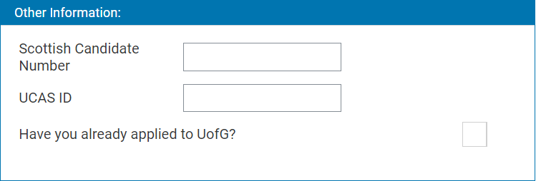

- If you have previously participated in another Widening Participation programme, please indicate this here. There is no limit on the number of programmes you can tick.

Note:
If you participated in University Experience Week, please tick Taster Week.

If you participated in a Widening Participation programme which is not listed, please tick None of above. If you have not participated in any Widening Participation programme, you can leave this part blank.

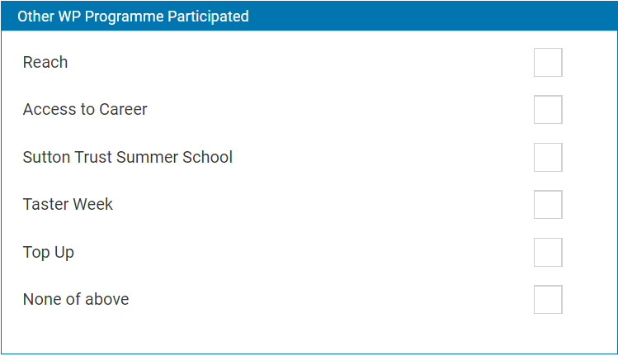

Section 5: Source of Information

- Please select from the drop-down how you heard about Summer School.

If Summer School forms a part of your conditional offer, please select Email – UoG. If you have been invited to take part in Summer School, you can select Staff from Glasgow University.

You can also leave further information about how you heard about Summer School, although this is not required.

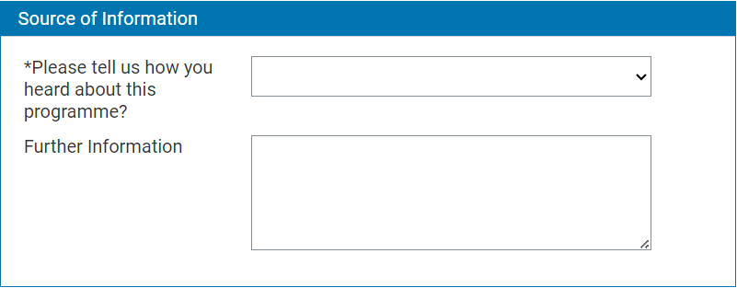

Section 6: Submit

- Here you will need to agree to the University’s Declaration and Privacy Notice.

Note:
If you have any questions about how the Summer School team uses your information, please contact us at wpsummerschool@glasgow.ac.uk.

Section 7: Application Overview

- This section allows you to view your registration form. By clicking each of the coloured boxes, this will pull all the information you have entered for each section. You can edit any piece of information by clicking the relevant section on the menu on the left-hand side of the page.

Note:
We would highly recommend that you thoroughly check your registration form before submission.

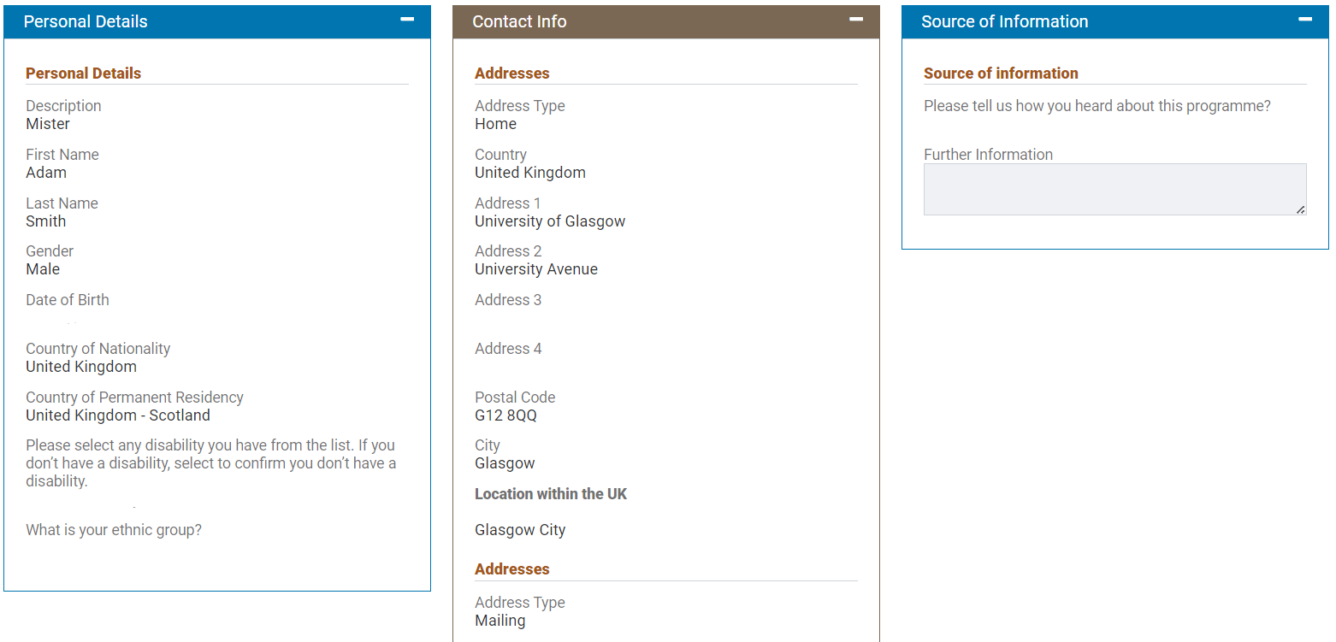

Once you are satisfied that your registration form is completed, please click Confirm details and submit. Your registration will not be submitted if you do not click this button!

Note:
You can come back and complete your registration later, by clicking the Save button and then click Logout. However, you must complete your application within 42 days of starting, as after this time any data is wiped, and you will have to start from the beginning.

Once you have submitted your registration, you will receive an automated email confirming that we have received it. This will arrive within 24 hours of submission of the form and will come from mycampus-admissions@glasgow.ac.uk. The subject header in the email will be: Application Acknowledgement from the University of Glasgow

At the top of this email is your Unique Glasgow Identifier (GUID/Student Number), please note this down as you will need it. Within this email is a link to a second form (we no longer need you to complete this, please disregard).

Participants are required to complete an induction session. These will be held online and in person in the weeks beginning 2nd and 9th June. Information on how to register for a session will be sent to you. Academic courses begin on Monday 16th June and will complete on Friday 11th July. All students are required to complete all modules in order to pass the course. Students should plan to attend every class. All students will be required to complete all assessments by the deadlines. Late submissions will be subjected to deductions in grades.

If you have any questions at all during this process, please contact the Summer School team on wpsummerschool@glasgow.ac.uk quoting your UCAS ID where possible. Please allow up to 3 working days for a response and please note that the team are available Monday to Friday from 9am until 5pm.

Summer School registrations can be submitted before you have made your UCAS decision. If Summer School forms a part of your conditional offer, or if you have been recommended to attend, you will be guaranteed a place on the programme. Some subjects will be in high demand and therefore we will allocate you to the most appropriate subject for your undergraduate degree choice and conditional offer. If Summer School forms a part of your offer and you do not attend, you will not fulfil the conditions of your offer of entry to the university.

If you have any questions about your conditional offer of entry, please contact the Summer Programmes team at wpsummerschool@glasgow.ac.uk

