

School of Chemistry

SAFETY MANUAL FOR THE HANDLING
OF LIQUID AMMONIA

No researcher should use ammonia (gas or liquid) unless they have read and understood these notes [including Vogel's Textbook of Practical Organic Chemistry, 5th Edition, Longman (1989) pp 116–120] and have agreed to abide by the recommendations, protocols and prohibitions contained herein. Your research supervisor must be aware that you are engaged in such work, and other occupants of the laboratory should also be informed. The protocols outlined in this manual constitute a COSHH assessment.

2013
Liquid Ammonia
Liquid ammonia is an extremely corrosive cryogenic material which is destructive to human tissue. It can cause serious burns if splashed on the skin, is very damaging to the eyes, and can cause corneal ulcers. The vapour is a powerful irritant to the eyes and mucous membranes of the upper respiratory tract and has TLV 25 ppm.
Although ammonia vapour is difficult to ignite, relatively high concentrations in air can ignite. In the event of a fire, ammonia-air mixtures can detonate. The neat liquid should be regarded as highly flammable.

1. Properties
Liquid ammonia is a colourless liquid, with a boiling point of –33.4 °C freezing point of –77.7 °C (colourless solid). It has a relatively high latent heat of vaporisation, and hence evaporates slowly from Quickfit glassware. Consequently, it is not usually necessary to contain liquid ammonia in a double-walled (i.e. Dewar) vessel and usual reaction assemblages will suffice. To reduce the rate of evaporation and limit icing of the external flask wall, an insulating layer of rock wool, vermiculite or of glass wool contained in a beaker can be employed. However, ammonia vapour is generated continually, so a vent is required and an inert gas atmosphere is usually not necessary. The liquid is an excellent solvent for organic compounds having a range of polarities, and also for metals such as lithium, sodium, potassium and calcium.

2. Precautions
- Liquid ammonia should never be used outside normal working hours.
- You must always work in a fume hood in a well ventilated laboratory.
- You must wear adequate eye protection for the operations you intend to perform and wear a full face shield if splashing is likely.
- Always wear thick rubber gloves while handling or dispensing ammonia.

3. In the Event of an Accident
If containment is lost and ammonia (liquid or gas) enters the room, clear the laboratory immediately. Re-entry should only be permitted in the following circumstances:
- Breathing apparatus, a laboratory coat and heavy rubber gloves are worn.
- A second person is available as back-up immediately outside the affected area – this person should keep the person entering the area in full view so that immediate assistance can be given if necessary.
- Risks are avoided during the clear-up operation. The simple remedy of opening the laboratory windows to improve ventilation may suffice, but the Section Safety Officer should be consulted.

4. First Aid
Exposure of eyes and skin
- Flush all affected areas with copious amounts of water.
- If the event that eyes are contaminated, it is important that they are irrigated with cold, clean water for at least 15 minutes.
- Unless exposure is very minor, one should seek professional medical attention immediately.

Inhalation
- Remove the person from the source of exposure, rest and keep warm.
- In severe cases where exposure has been significant, obtain medical attention immediately.

Ingestion
- If material is swallowed, wash out mouth thoroughly with water and give plenty of water to drink then seek immediate medical attention.

4. Incompatible Compounds
Liquid ammonia reacts vigorously and often explosively with a wide range of substances. You must check for possible incompatibilities before embarking on a reaction in this solvent. A list (non-comprehensive) of some of the incompatible compounds follows:
- All of the halogens and most of the inter-halogens.
- Acids, acid chlorides and acid anhydrides.
- Chloroformates and chlorosilanes.
- Acetaldehyde.
- Boron or BI₃.
- CrO₃ and chromyl chloride.
- Many other oxidising agents, and especially NO₂/N₂O₄ or NCl₃.
- P₂O₅ and P₂O₃.
- Chlorites and chlorine oxides.
- Galvanized iron, zinc, copper, silver, gold, mercury.

5. Dispensing Ammonia from a Cylinder
Several types of ammonia cylinder are available: those which dispense gas only when held upright but deliver liquid ammonia when supported by a cradle with the valve facing down, and those with an inner tube which reaches to the bottom of the cylinder and deliver liquid rather than gaseous ammonia at an appropriate flow rate, even when the cylinder is held in an upright position. You must check which type of cylinder you have before starting your experiment.

Liquid ammonia by condensation of gaseous ammonia
Please refer to Vogel's Textbook of Practical Organic Chemistry, 5th Edition, Longman (1989) pp 116–120 for apparatus set up before beginning your experiment. Your apparatus must be equipped with a vented acetone-dry ice cooling condenser, and the collection flask must also be cooled in an acetone-dry ice bath. Take care not to set the flow rate too high, otherwise the coolant will boil-off rapidly and most of the ammonia will escape through the vent. The condenser will need to be regularly topped-up with solid CO₂. About 500–600 mL of redistilled liquid ammonia can be collected in approximately 30 min in this way.

Liquid ammonia directly from a cylinder
Liquid ammonia can be obtained directly from a cylinder which incorporates a simple valve and a wide-bore outlet [see Vogel's Textbook of Practical Organic Chemistry, 5th Edition, Longman (1989) pp 116–120] or from a cylinder with an inner tube which reaches to the bottom of the cylinder (you must check which type you have before starting to dispense ammonia). In the former case, only ammonia gas will be released when the cylinder is sitting upright (outlet valve at the top) and the cylinder must be supported in a special cradle (valve down) in order to obtain liquid ammonia directly. In the latter case, the cylinder will deliver liquid ammonia even when the cylinder is held in an upright position, provided there is an appropriate flow rate. For both types of cylinder, delivery is made through plastic tubing which must be wired on to the cylinder. The cylinder must be positioned alongside or inside (depending on cylinder size) your fume hood in such a way that the exit tube is totally within the fume hood while dispensing ammonia. It is essential that a competent person shows you how to accomplish the safe transfer of ammonia from the cylinder into your flask. Liquid ammonia must never be used outside normal working hours.
When dispensing liquid ammonia, the plastic outlet tube should run into the receiver flask via a suitable adapter (tube 'wired-on') inside the fume hood. It is advisable to support the plastic tubing by means of a retort stand and clamps during delivery. The initial force of ammonia release can make the tubing flex, causing damage; during the passage of the cryogenic liquid the tubing will harden and stiffen, which can also lead to damage of the apparatus if the tube is not supported.
When opening the valve, be careful not to do so too quickly. Only ammonia gas will emerge until the cylinder valve, valve outlet and adapter, and the plastic tubing have cooled to –33 °C. After a short while, liquid ammonia should flow into the flask. When the flask has cooled to –33 °C, gradually fill it. The flask selected should be of such a size that it is only half full when the required volume of liquid has been obtained. The flask should be pre-marked to indicate when this volume is reached.* Immediately after charging the flask the contents should be protected from atmospheric moisture by inserting curved outlet tubes or plugs of wadding. The small amount of water vapour that is condensed during this operation is usually not a problem, but can be kept to the minimum by attaching a dry ice condenser to the flask before charging; the outlet from the condenser should be connected to a loose-packed soda-lime tower and any unused necks in the flask should be closed-off after subsidiary pieces of equipment (e.g. mechanical stirrer, a pressure-equalising dropping funnel with stopper, etc.) are in place. Additionally, the flask should be insulated using rock wool or some other lagging material. External cooling is not usually applied. Do not use calcium chloride guard tubes.
Note:
* After turning off the cylinder valve, allow the ammonia to drain out of the plastic tube fully (e.g. until the plastic has softened) before removing the tubing from the fume hood.

6. Purification of Ammonia
Liquid ammonia taken directly from the cylinder is relatively dry, but typically will contain traces of water (approximately 0.1–0.5 gL^{–1}) after collection. A crude gauge of the water content can be accomplished by adding (with stirring) very small pieces of sodium; the blue colour of the dissolved metal very quickly disappears as long as water is present. The sodium hydroxide formed is almost insoluble and may interfere only in a few special cases.
A common contaminant of liquid ammonia (direct distribution method) is iron in colloidal form or as dissolved salts. Iron contaminants have a deleterious effect on Birch reductions, and re-distillation of the liquid ammonia is beneficial for such applications. However, flask-to-flask re-distillation is slow due to the high latent heat of vaporization of ammonia, and should be performed only when necessary. If iron-free ammonia is essential, then it is best to withdraw gaseous ammonia from the cylinder and condense it in your apparatus.

7. Reaction and Work-up
Apparatus
Simple apparatus is usually employed – typically a three-necked Quickfit flask equipped with a mechanical stirrer (centre-neck), an addition funnel (one side-neck) and an air condenser topped with an empty drying tube as the gas outlet (other side-neck) [see Vogel's Textbook of Practical Organic Chemistry, 5th Edition, Longman (1989) p119]. The air condenser prevents splashing out of the mixture during vigorous stirring. If a solid reagent is to be added, the addition funnel is replaced by a stopper which is removed during the addition of this reagent. During very vigorous reactions, the gas outlet on the air condenser can be omitted. The intensity of the stream of escaping ammonia gives an impression of the rate at which the reaction is proceeding. The flask contents can be viewed by the removal from time to time of a section of the external ice coating by pouring a few drops of acetone or ethanol on to the outside of the flask from a wash bottle.
In some cases, it is necessary to compensate for losses of ammonia due to evaporation, although this can be minimised to some extent by placing the flask into a vessel packed with an insulating material. However, topping-up may be unavoidable for long-term reactions or when two or more conversions are to be carried out in the same flask (e.g. deprotonation and alkylation of alkynes).
Some workers use an acetone-dry ice reflux condenser to prevent evaporative losses. However, this method is relatively expensive because a considerable amount of solid carbon dioxide is required; moreover, the acetone-dry ice mixture foams and splashes rather vigorously.
If the reagent in the addition funnel is attacked by the gaseous ammonia, a crust will form and block the addition funnel. This problem can be avoided by adding the reagent through a tube which dips below the surface of the liquid ammonia in the flask and through which nitrogen is blown (Figure). Examples of liquids which are attacked by ammonia vapour are methyl iodide and methyl vinyl ketone.
In some procedures, notably those involving dehydrohalogenation reactions, the use of a round-bottomed flask containing a single wide neck is specified. The halogen compound is cautiously poured into the flask which contains a suspension of alkali amide in liquid ammonia. During addition, the mixture in the flask is swirled manually (rubber gloves required). The very vigorous stream of ammonia vapour prevents the entry of atmospheric moisture during the short reaction time (usually <30 minutes). However, such reactions should be conducted – with much less risk – using a slower rate of addition and the conventional apparatus above.
In the general procedures discussed above, external cooling (i.e. to –78 °C) has not been applied since these procedures involve neat liquid ammonia (freezing point –77.7 °C). Some procedures, require the use of a co-solvent (e.g. THF) and an acetone-dry ice bath. In these cases, it may be necessary to make minor modifications to the above protocols which should be discussed with your supervisor.
For standard Birch reduction procedures see Vogel's Textbook of Practical Organic Chemistry, 5th Edition, Longman (1989) pp 1114–1117.

Work-up
The simplest work-up procedure for non-volatile reaction products and products which are obtained in the form of alkali metal salts is to allow the ammonia to evaporate slowly through the vent at the back of the fume hood. Often, an inert solvent such as diethyl ether or THF is added to the flask before evaporation commences. If time is important, the flask may be placed in a warm water bath (~40–50 °C) and the flask contents stirred. In either case, a stream of nitrogen can be introduced if the product is sensitive to atmospheric oxidation. Subsequent treatment of the product will depend upon the particular reaction; literature experimental details should be consulted for typical isolation procedures. In cases where volatile reaction products are formed, special work-up procedures must be used to prevent loss during the evaporation of the ammonia. Consult the original literature procedure and/or the references above.

Further details of reactions and experimental techniques are available in Brandsma, L. Preparative Acetylene Chemistry, Elsevier (1971) or in Vogel's Textbook of Practical Organic Chemistry, 5th Edition, Longman (1989) pp 116–120 and 1114–1117.
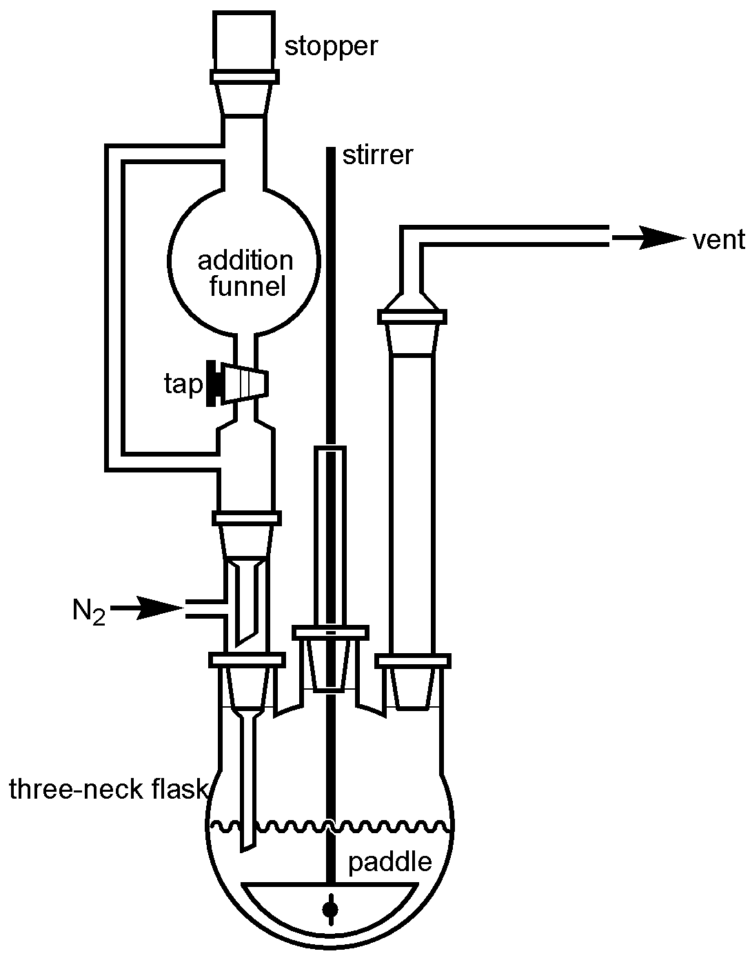
Figure

