The Electromagnetic Fields at Work Regulations 2016

Introduction

Directive 2013/35/EU (termed "the Directive") came into force early 2017 and covers all artificial sources of electromagnetic fields. The Directive is all-embracing and covers all electrically powered equipment from trivial through to more dangerous sources. The directive requires an assessment be made for all sources.

In particular, the Regulations covers any device which may emit one or more of the following; static electric or magnetic fields, time varying electric or magnetic fields, spatially varying electric or magnetic fields or electromagnetic fields.

Not all devices satisfying the above criterion are hazardous, in fact, the vast majority of devices in common use throughout the University fall into the category of ‘insignificant’

Definition

For the purposes of the Regulations EMF’s are defined as static electric, static magnetic and time varying electric, magnetic and electromagnetic fields with frequencies up to 300 GHz.

Health Effects

Common health effects from exposure to the above fields are given in the table below.

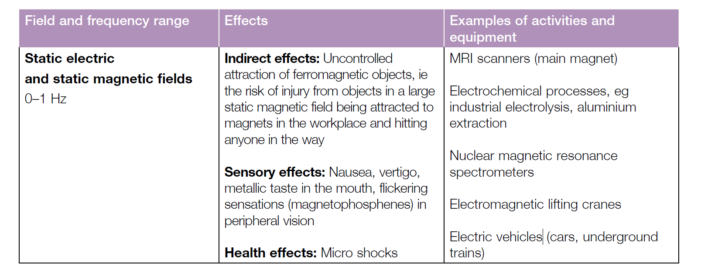
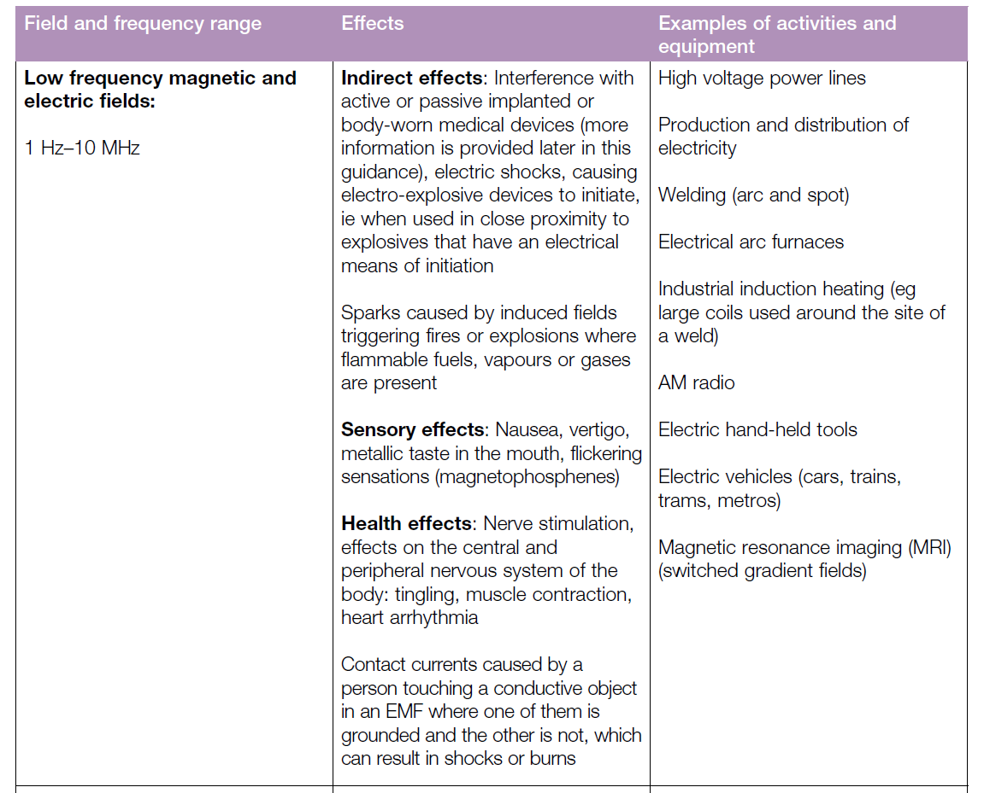
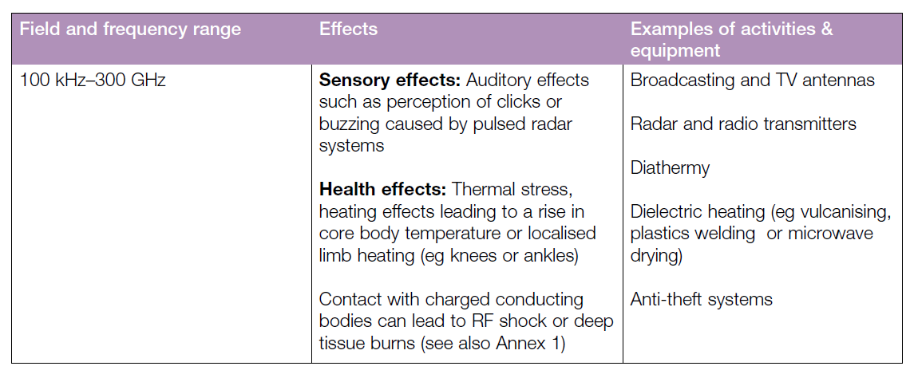

Scope
This guide provides a link (Table 3.2, pages 24 – 27 of Electromagnetic Fields – a Practical Guide) to a list of generic work activities, equipment and workplaces where fields are expected to be so weak that employers will not need to take any further action other than completing an inventory of devices covered under the Regulations. The EMF Directive requires employers to consider workers who are likely to be at particular risk, including workers who wear active or passive implanted medical devices, such as cardiac pacemakers, workers with medical devices worn on the body, such as insulin pumps, and pregnant workers. This guide provides a link to further advice in these situations.

What needs to be done?

An inventory of all electrically powered devices needs to be completed; from this, a list of devices, which may require further assessment, needs to be assembled. A list of common devices for which no further action is required (Electromagnetic Fields – a Practical Guide) can be found on our website.

If risks are not low, or are unknown, employers should follow a process to assess the risk and implement appropriate precautions, if necessary.

Please check our PowerPoint presentation ‘EMF’ and the document ‘Electromagnetic Fields – a Practical Guide’ for further details and guidance.

James Gray
University Radiation Protection Adviser July 2018

